KIDDERMINSTER FOREIGN PARISH COUNCIL
CHAIRMAN:
Councillor B. Phillips
Tel: 01299 861419
CLERK TO THE COUNCIL:
Mrs E. Whitehouse
Tel: 01299 861026

You are summoned to attend

A MEETING OF THE PARISH COUNCIL
to be held at

TRIMPLEY VILLAGE HALL
on
MONDAY 19th May 2014
at 7.45p.m.
(Please note date, venue and time of meeting)
Members of the public and
the press are welcome to attend.
The meeting will commence with a
PUBLIC LOCAL FORUM with planned attendance by West Mercia Constabulary officer
The Agenda for the Parish Council meeting is attached.

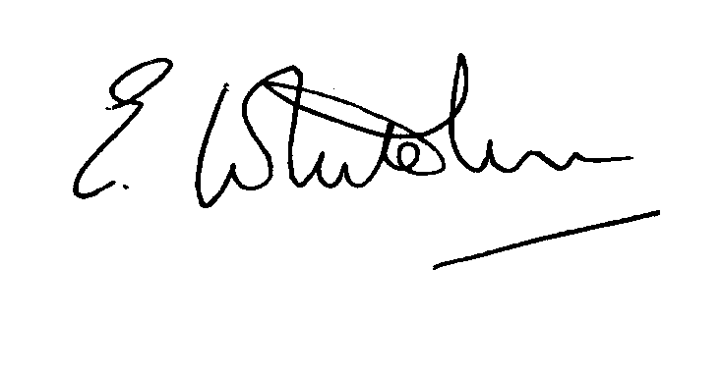

Dated: 12th May 2014 Clerk to the Council

e-mail: clerk.kiddfor.pc@googlemail.com

A G E N D A

(Note: The notation (I) indicates that the item is for information; (D) indicates that it requires a decision)
 | Police Report and Public Local Forum
 | Apologies for Absence and Approval of Reasons.
 | Declarations of Interest.
 | Approval of the Minutes of the Meeting of the Parish Council held 28th April 2014 |  | Enclosure 1
 | Planning and Development Control.
 | a.  b. | Update on previous applications considered - inc:  14/0065 - Creation of 1 Unit holiday let accommodation with access, parking and associated works at ROCK HOUSE, LOW HABBERLEY, KIDDERMINSTER, DY115RQ  14/0146 Reconstruction of roof structure to form additional accommodation. Amendments to approved application 13/0320/full at HIGH ACRE, TRIMPLEY, BEWDLEY, DY121NG  14/0212 – The Lodge, Park Attwood, Trimpley, Shatterford  Change of use from Shooting Lodge to Residential Dwelling  New applications received, up to the date of the meeting – None as at date of agenda. | (I)  (D)
 | c. | Compliance Issues  Update. | (I)
 | Progress Reports / Matters Arising – inc. Highway matters  a) Low Habberley - work on flood relief plans  b) Flooded footpath, Trimpley Common  c) Severn Trent matters  d) Remembrance flower planting |  | (I & D)
 | Newsletter – Items for next edition.  Request for approval for any costs incurred on research. |  | (I)
8. | Lengthsman  Tabling of any invoice for work undertaken. |  | (D)
9. | Financial Reports and Payment of Accounts.
 | a) | Payments  Any invoice tabled by the Lengthsman  PAYE re Clerk  Internal Audit fee | (D)
 | b) | Internal Audit report | (I)
10. | Worcestershire CALC Reports and Notices |  | (I)
11. | County and District Council Matters and Other Correspondence.  Reminder of Police event – “A journey through Justice” – 8th June 2014 |  | (D)
12. | Any report from the County or District Councillor representatives not already tabled
13. | Road Accident Record
14. | Other matters which the Chairman, after consulting members, feels to be of an urgent nature
15. | Next Meeting: 16th June 2014 – being the Annual Meeting of the Parish Council. |  | (D)

