FINSTALL PARISH COUNCIL
_____________________________________________________________________

Tel: 07967043076
Email: finstallpc@live.co.uk

26th April 2022

Dear Councillors

I hereby summon you to attend the next meeting of Finstall Parish Council which will be an Ordinary Meeting of the Council and held at the Village Hall on Tuesday 3rd May 2022 at 7.30pm

Yours sincerely

Sarah Whittkaker

Clerk and Proper Officer
………………………………………………………………………………………
PUBLIC PARTICIPATION:

From 7.30 pm residents are invited to give their views and question the Parish Council on issues on this Agenda, or raise issues for future consideration at the discretion of the Chairman, before the start of the Parish Council meeting at 7.40 pm. Members of the public may not take part in the Parish Council meeting itself.

A G E N D A

1. To receive and approve any apology for absence, with reasons please.

2. To receive, approve and sign pages 04/22 P 1253-1255 recording the Meeting held on Tuesday 5th April 2022.

3. DECLARATION OF INTEREST:

a) Register of Interests: Councillors are reminded of the need to update their register of interests.
b) To declare any Disclosable Pecuniary Interests in items on the agenda and their nature.
c) To declare any Other Disclosable Interests in items on the agenda and their nature.

Councillors who have declared a Disclosable Pecuniary Interest, or an Other Disclosable Interest which falls within the terms of paragraph 12(4) (b) of the code of conduct, must leave the room for the relevant items.

Failure to register or declare a Disclosable Pecuniary Interest may result in the commission of a criminal offence.

4. UPDATE FROM NEIGHBOURHOOD POLICE TEAM

To receive a verbal update from the neighbourhood policing team.

5. PROGRESS REPORTS FOR INFORMATION:

- The Clerk had made the amendments to the draft Risk Management Policy sent by councillors
- The Clerk had sent details of a suitable printer for purchase
- There had been one further response regarding the Community Payback scheme from a local parish council. The council had not previously used the scheme and had no plans to do so.
6. CORRESPONDENCE

- Insurance renewal information – sent 19th April 2022
- Updated police contact details – sent 20th April 2022
- 21 day road Closure – sent 19th April 2022

7. PLANNING APPLICATIONS FOR CONSIDERATION:
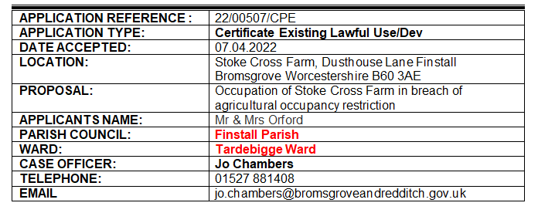
Planning Approvals: None to date
Planning Refusals: None to date.

8. INSURANCE RENEWAL

To consider the annual renewal, which remains the same as last year, at a cost of £495.02.

9. RISK MANAGEMENT POLICY

To consider the updated Risk Management Policy for adoption by the parish council.

10. ROSPA PLAYGROUND INSPECTION

To consider the findings of the annual ROSPA inspection.

11. FINANCE

- Receipts of £155.28 (See Schedule A(i) attached)

b) To consider and authorise payments of £1714.89 (See
Schedule A(ii) attached.

c) To approve the Bank reconciliation for March 2021.

d.) To approve the attached end of year accounts.

12. DATE OF NEXT MEETING:

Resolved: The next meeting will be an Ordinary Meeting of Finstall Parish Council to commence at 7.30pm on Tuesday 7th June 2022.

13. OTHER MATTERS FOR DISCUSSION ONLY - not referred to in
the Agenda.
Bank Account Summary

HSBC Money Manager 40 15 07 01613189 £1696.66
(to 30th March 2022)
HSBC BUSINESS ACCOUNT 40 15 07 51613170 £3978.67
(to 30th March 2022)

BDC Temporary Loan Account £15500

SCHEDULE A(i): RECEIPTS

Interest Money Manager Account 0.03
Worcestershire CC (Lengthsman) 155.25
£ 155.28

SCHEDULE A(ii): PAYMENTS

S. Whittaker – April Salary & expenses 235.84
S.Whittaker – Printer Purchase 99.99
Three Counties Payroll (DD) 50.04
S. Skeys – April Invoice (awaiting invoice)
ROSPA Play Inspection 84.00
BHIB Insurance 495.02
Parkgate Nurseries (Christmas Trees x 5) 750.00

£1714.89

