BROOME PARISH COUNCIL

Clerk to the Council: – Mr Marcus J. Hart
Apartment 2, Woodhamcote Manor, DY11 5XZ
01562 851769
marcushart78@yahoo.co.uk

Chairman – Cllr. Don Billington

To the members of Broome Parish Council, Parishioners and General Public:-

You are duly invited to attend the Annual Parish Meeting of Broome Parish Council on Wednesday 2nd May, 2018 at 7:30pm at Broome Village
Hall

AGENDA

- Welcome

- Apologies

3. Minutes of the meeting held on Wednesday, 3rd May, 2017

- Matters Arising

- Presentation by Mr Adnan Ali from West Mercia Safer Roads
Partnership on the setting up of a Community Speed Watch

- Chairman’s Annual Report

- Broome United Charities - Report from Mrs Diana Pheysey

- Tree Warden

- Chaddesley Education Foundation – Report from Mr David Pheysey

- Public Questions
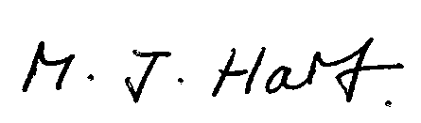
Marcus J. Hart
Clerk to Broome Parish Council

