M5 J6 Junction Improvement

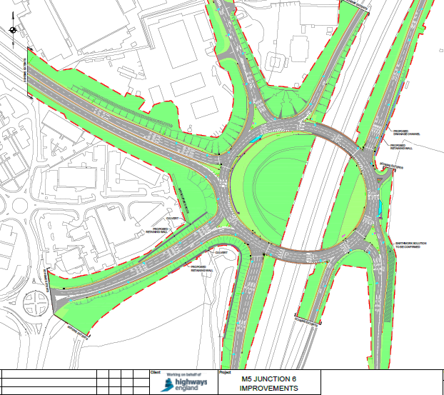
Traffic signals
Traffic signals
Traffic signals
Traffic signals

