BRIEF HISTORY OF THE PARISH OF MARTIN HUSSINGTREE
by Barbara Meddings
1/3

MARTIN HUSSINGTREE

12th cent. Hosintre et Merton; 14th cent. Merton and Hosintree;
16th cent. Mertonhosentre; 17th cent. Martin Husyngtree, Marten Hussentree.
( Names evolved of Saxon origin: Husa’s Tree = persons name of Husa and
Mereton = farmstead or estate by the mere)

PARISH and Conservation Area

The parish covers an area of 922 acres and lies on the north side of Martin Brook.
The Brook joins the River Salwarpe at a south western angle as the river continues on
to form the western boundary of the parish at Brookhill. The Droitwich Canal cuts
through on the west side, with the Railway and the Droitwich A38 (old Roman Road) to Worcester running parallel south through the centre of the parish.

Martin Hussingtree consists of small scattered settlements forming an ancient hamlet of houses and farms and the main part of the hamlet is a mile north-east of Fernhill Heath. At the south end of the parish, off the A38 Worcester road is located
St Michaels and All Angels church of 12th century origins, (originally dedicated to St Nicholas), with the Old Rectory opposite. Martin Court Farm to the west of the church, was formerly the manor-house dating from the 18th century and has inside a post called the Gospel post. On the lane from the church are some old half-timbered cottages all within a Conservation Area.

North of the Conservation Area, on the A38 to Droitwich road at the junction of A4538 Pershore Lane is ‘Martin Green’ in the ownership of the Parish Council
from 1973.

At one time there were three pools on the Green. On the larger part of the Green
was one pool that gradually silted up. The second pool adjacent to the Worcester
Road almost opposite Drury Lane was filled in during the 19th century. The third
adjacent to Ash Lane; the Parish Council in 1999 cleared the pool and planted the
area around it protected by wooden posts.

Brownheath on the eastern boundary, a 17th century Common of about 7 acres of rough pasture land. During the 18th century a number of houses and cottages were
on and around the Common. The once open space of Brownheath Common is now
woodland administered by the Parish Council.

THE MANORS

972 By a charter ascribed to King Edgar, five manses at Husantreo (consisting of
estates or farms of Brookhill, Caulin Court, Martin Hall, Hill House,
Saints Farm and part of Hindlip Stables.

2/3

The five manses at Merton (Merton Manor) restored to the abbey of Pershore.
Early undated reference to grant to all the land belonging to Howsintree
butting on the land of William de Mertun.

1086 Domesday book: Hussingtree only is entered. Martin and Hussingtree were
two separate manors.
1269 Recorded: Thomas de Pirie (Perry.Pyrie)
1280 Taxed together with the name written Hussintre et Merton.
1372 Recorded Richard de Hosentre
1419 Thomas Hussingtree was probably lord of Hussingtree.
1536 Reference to the order of the names being reversed to Merton and Hosintre.
1537 John Ruding of Hussingtree was a suitor at the court of Allesborough,
probably on account of his tenure of the estate held by the Rudlings.
1569 Recorded, the estate was later held by the Rudlings.
Few records survive.
1619 Records show Hosyntre sold to Sir Edmund Wheeler of Martin Hussingtree
succeeded by his son William.
No further trace of property occurs save for an undated note that Lord Sandys
sold the manor of Hussingtree.
1746 Martin Court was the manor house of Merton and its estate.
18th Century merged as one manor known as Martin Hussingtree.

TRACKS of great antiquity in the parish

During the Roman occupation the area around Ladywood was covered by a
vast forest within which lay clearings of small settlements. The Romans established
a network of saltways and tracks for carting wood to fuel the saltpans of Droitwich
until mid 16th century.

The ancient lane from Brookhill (in Martin Hussingtree Parish) up through Ladywood
forking left into the parish of Salwarpe still remains.

An ancient track continues from Drury Lane as a footpathacross the A38 onto the North side of the Swan Inn joins the end of Ash Lane leading to Brownheath Common. A bridle way commencing at Ash Lane also leads to Brownheath.

The main road from Droitwich is pre Roman and was part of a saltway later called Lower Saltway. AD43-AD410 the Romans re-routed the Lower Saltway at Sandy Way, Martin Hussingtree crossed Martin Brook ( formerly named Broad Ford) cutting a new saltway across the southern edge of Hindlip Park to Spellis Green.

A second Roman track from Sandy Way ran east across Pershore Lane to top of Smite Hill to Oddingley named ‘Green Weg’. In 1864 it was closed to carts and defined as a footpath. It retains its name as Green Lane within Oddingly.

3/3

CANAL - Ladywood (Levediwode)

1771 Droitwich Barge Canal built by James Brindly cuts through lower Ladywood
to Porters Mill (formerly Tappenhall Mill) linking to the River Severn as
a transport system for the salt industry. The canal and its surrounding is
a Conservation Area.

RAILWAY

1840 Oxford-Worcester-Wolverhampton Railway runs from the southern
boundary of the parish at Martin Brook through farm land, bridged at
Strand Lane, Ladywood and continues to the northern boundary with
Salwarpe parish.

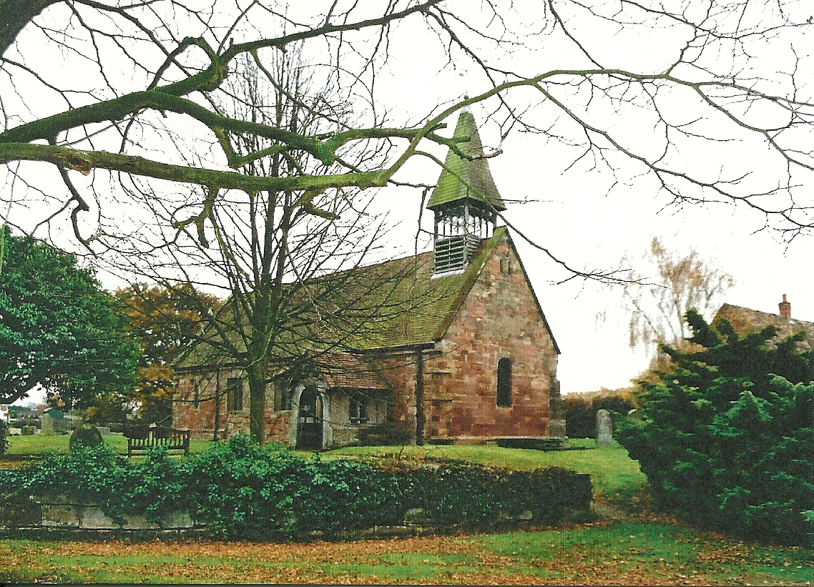

St Michaels All Angels Church, Martin Hussingtree

4/4

Acknowledgements:

Text: Extracts from Books: ‘Of the Parish Here and There’
(The History of Martin Hussingtree). ‘The History of Fernhill Heath’
(The Village of North Claines). Gill Lawley
by kind permission of Trevor Lawley.

Citation: ‘Parishes: Martin Hussingtree’, A History of the County of Worcester:
volume 4 (1924), pp. 135-139. URL: http://www.british-history.ac.uk/report.
aspx?compid=42868 Date accessed: 28 January 2010.

