BRIEF HISTORY OF THE PARISH OF SALWARPE
by Barbara Meddings
1/4

SALWARPE

9th cent. Salewearpe,Salowarpa; 11th,12th & 14th cent. Salewarpe;
14th cent. Saltwarp; 16th cent. Sulwarp

PARISH and Conservation Area

Salwarpe parish covers an area of 1,914 acres, with the River Salwarpe and its
tributary the Hadley Brook forming the western boundary. The road from Ombersley joining the A38 Droitwich new Bypass (Roman Way) forms the northern boundary to
the new roundabout. The main A38 old Roman road from Droitwich to Worcester passes through the parish and at Copcut (Coppecote) where an Inn/Hostelry has historically been on the site, now a Public House. A lane opposite the Copcut forms
the north-eastern boundary via Pulley (Pulheye) to Newland Common. The M5 Motorway running south to Hull Farm (Washpool Lane) forms the southern boundary.

The small village of Salwarpe is situated on the slope of a valley through which runs the River Salwarpe. The Old Rectory (now Salwarpe House) the church and its
burial ground are separated by a steep cutting of the Worcester to Birmingham canal;
from Salwarpe Court a half timbered house of the late 15th century, the ancient seat
of the Talbots. Richard Beauchamp thirteenth Earl of Warwick was born at Salwarpe on 28 January 1381.

The road (Copcut Lane) runs north-west from the A38 leading to the village and
Conservation Area and is bordered by clusters of historic houses and cottages;
Churchfields Farmhouse, Cookshill cottage (now The Tappit Hen), Churchfields
cottage; Hill End House (Hyllend), and the Old School House. The road crosses the canal by a red brick bridge and descends by Lychgate and Church Cottages to Mill cottage and the Old Mill House (formerly Corn Hill House) where Salwarpe Water Mill stood and was demolished in 1942.

On the north side of the River Salwarpe, and within the parish, the land rises
to High Park House, Coach House and Jacobean Farmhouse with malt house outbuildings located on the south side of the A4133 road to Ombersley. Records show that in 1813 the majority of land and accesses of Salwarpe and Copcut were
owned by Philip Gresley, Lord of the Manor who lived at High Park.

Among the place-names are Coppecote, Middleton, Hyllend, Pulheye, Leverdiwode.
Of these Copcut, Middleton, Hill End, Pulley and Ladywood still survive.

THE MANORS

817 According to a Saxon charter Salwarpe was granted by Coenwulf, King of
the Mercians, to Deneberht, Bishop of Worcester and his church.
1086 Domesday book: Park belonging to D’Abitot under Church of Coventry
1102 Overlordship remained with the Crown
2/4

1347 Reference is made to William de Salwarpe
1406 The manor held by the Prior of Coventry
1487 The manor passed into the hands of Henry VII.
Later Salwarpe was settled on Katherine of Aragon when she
married Prince Arthur, and she continued to hold it until her death.
1545 The manor was granted to Hugh Davie and George Wall
1546 Sold to John Talbot a grandson of the second Earl of Shrewsbury.
1582 Olive third daughter of Sir Henry Sharington of Lacock conveyed
her interest to her eldest son Sharington.
1644 His son Sharington, a zealous Royalist was taken prisoner and
confined to Warwick Castle.
1677 John Talbot settled the Manor on his second wife Barbara daughter
of Sir Henry Slingsby and mortgaged it in 1705
1712 Manor sold to settle debts of John Talbot. Purchased by his grandson
John, son of Sir John Ivory.
1738 Manor sold to Philip Gresley.
1822 Settled on Robert Archibald Douglas son of General Archibald
Douglas of Witham.
1885 Salwarpe passed to William Willoughby Douglas, rector of Salwarpe.

CHURCH

The Church of St.Michael. The earliest part of the present church is the nave
arcade, dating from the 12th century. In the middle of the 15th century a new
tower was built.

MILLS

1086 Urse D’Abitot had a mill in Salwarpe and it passed with the manor to the
Beauchamps and Talbots.

Another mill in Salwarpe was granted by Wulfstan, Bishop of Worcester, to the
Prior and monks of Worcester and confirmed to them by William the Conqueror.
1322 two mills in Salwarpe. Sir John Lyttelton of Frankley died in 1590 holding
a windmill at Salwarpe. His son Gilbert seems to have built two water-mills there,
one of which he called Sowleys or New Mills.

There were two water-mills at Salwarpe, one in the village and the other
called New Mill on the borders of Ombersley.

CELVESTUNE (Chalvestona)

1086 William Goizenbolded held land at Celvestune. In time this land was held
by William de Beauchamp. The manor probably became absorbed in the manor of Salwarpe.

3/4
CHAWSON (Chauson, Chawston)

A house at Chauson of the late 16th or early 17th century is supposed to have been
the residence of the Richardsons. A family of Richardson of ‘Chawston’ whose
arms were recorded in the time of Charles 1, appear to have been citizens of Worcester who were numbered among the gentry of the shire in 1660 and
perhaps built a country residence at Chauson.

OAKLEY

Oakley, situated in the east of the parish and now only a farm-house, was the site
of a reputed manor which probably at first belonged to a family of the same name.
Recorded, is Richard son of William de Oakley recovered two parts of land at
Salwarpe in 1274. The manor of Oakley with manor-house dated 1770.

TRACKS of great antiquity in the parish

During the Roman occupation the area around Droitwich was covered by a vast
forest within which lay clearings of small settlements. The Romans established a
network of saltways and tracks for carting wood to fuel the saltpans of Droitwich.
Many now defined as footpaths.

The ancient lane from Brookhill up through Ladywood forking left towards
Salwarpe still remains.

CANAL

1771 Canal Bridge in Salwarpe Village built by James Brindley is a
Grade II Listed Building. Droitwich Barge Canal runs through Salwarpe Village
via Ladywood linking Droitwich with River Severn built as a transport system for
the salt industry. The canal and its surrounds is a Conservation Area.

RAILWAY

1840 Oxford-Worcester-Wolverhampton Railway was bridged in Copcut Lane, at the original junction of Middleton Bank lane near to the white thatched Middleton cottage, the lane being re-aligned to the west side of the of the bridge, when the farm lands of Middleton Farm and Middleton Grange were sold to the Railway. The steep embankment of the lane still retains the name of Middleton Bank.

4/4
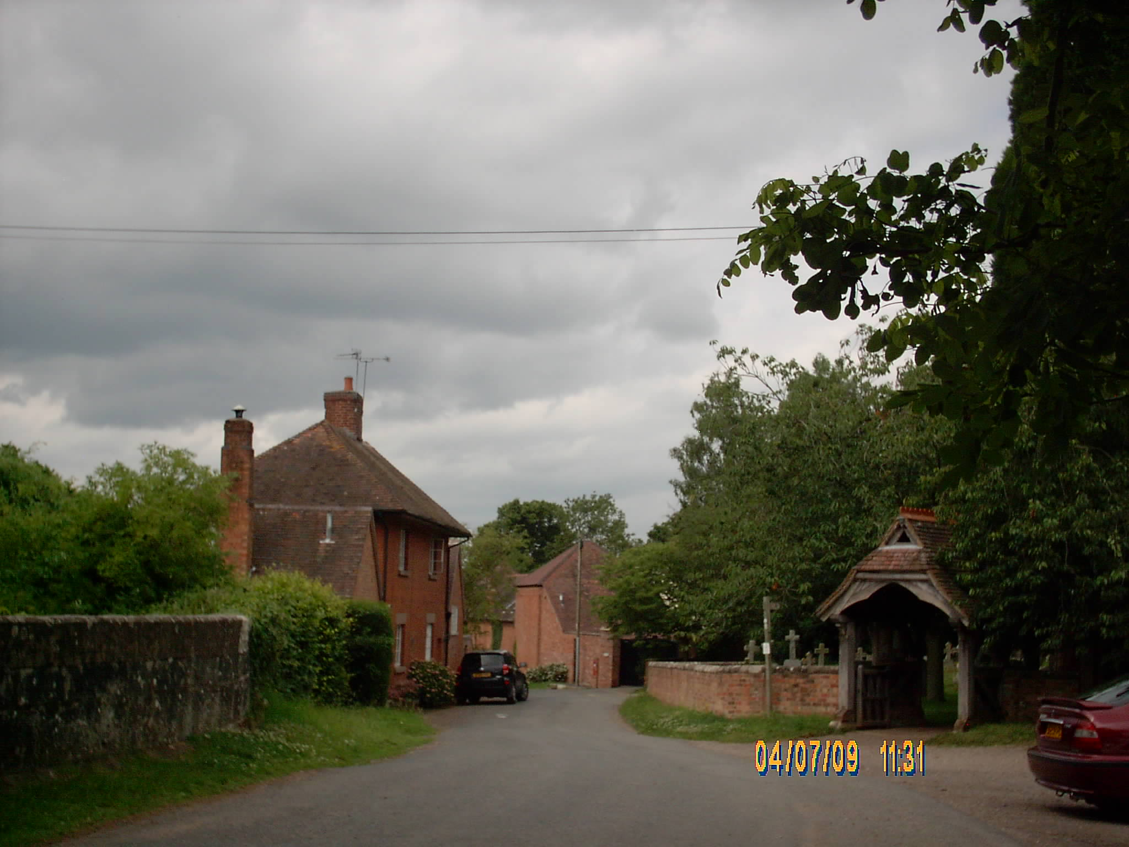

SALWARPE VILLAGE

Acknowledgements:

Text: Extracts from Books: ‘Of the Parish Here and There’
(The History of Martin Hussingtree). ‘The History of Fernhill Heath’
(The Village of North Claines). Gill Lawley
by kind permission of Trevor Lawley

Citation: ‘Parishes: Salwarpe’, A History of the County of Worcester;
volume 3 (1913),pp.205-210. URL: http://www.british-history.ac.uk/
report.aspx?compid=43110 Date accessed: 28 January 2010.

