Parish of Madresfield

NOTICE IS HEREBY GIVEN

that a casual vacancy has arisen in the Office of Councillor for the Parish Council following the resignation on 12th June 2020 of Councillor Julie Greenwood.

If within 14 days a request for an election to fill said vacancy is made in writing to the Returning Officer at the address below by TEN electors** for the said Parish, an election will be held to fill the said vacancy, otherwise the vacancy will be filled by co-option.

By virtue of the Coronavirus Act 2020 and The Local Government and Police and Crime Commissioner (Coronavirus)(Postponement of Elections and Referendums)(England and Wales) Regulations 2020 the by-election will not currently take place, and the vacancy will be held open until the by election takes place. The 2020 regulations provide for the by election to take place on Thursday 6 May 2021. However, this date may be brought forward or deferred by the Government depending upon the circumstances. Any Election that is In due course called will be duly publicised as required by law.

David Sharp
Clerk to the Parish Council:

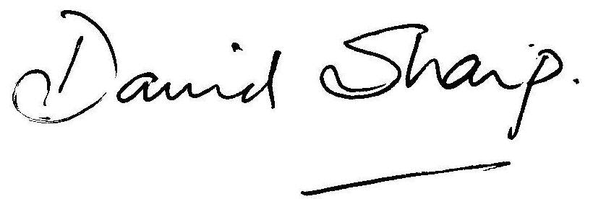

11th September 2020

Returning Officer
The Council House
Avenue Road
Malvern
WR14 3AF

** There is no form of words for this request, which might simply be a letter headed with such words as “We the undersigned being electors for the [Ward of] … Parish, call for an election to fill the vacancy arising from the [death][resignation] of …”. It is helpful if the ten signatures are accompanied by printed names and addresses.

