Lower Broadheath Parish Council
Chairman of the Council  Barbara Beard  4 Manorfield, Lower Broadheath,  Worcester WR2 6QN  Email: barbara@the-beards.co.uk  Tel. No. 01905 640139 | Clerk to the Council  Mike Davis  35 Oakfield Road, Malvern  Worcestershire WR14 1DS  Email: mikedavis@worldonline.co.uk  Tel. No. 01684 569864

Date: 24th November, 2010

Dear Councillor / Officer,

South Worcestershire Development Plan Submission

Lower Broadheath Parish Council has been extremely concerned about the former SWJCS and its effect on the parish and surrounding area. The SWDP affords the opportunity to address earlier concerns, but it is vital that any forecast housing need is soundly based. This paper is intended to inform discussion about the area’s demographics and I trust you will find it helpful.

Yours sincerely

Mike Davis

Mike Davis

Clerk to the Parish Council

South Worcestershire Development Plan

Consultation paper from Lower Broadheath Parish Council
16 Nov 2010

Although the Regional Spatial Strategy (RSS) prepared 'Options 2' document of December 2007 will be overturned by the new coalition government, weight is still being given to the ‘evidence’ it contains, both by local authority planning officials and elected members. Some of the Worcestershire County Council (WCC) population statistics appear to forecast a much lower rate of population than do the latest Office of National Statistics (ONS) figures. What evidence, to refute the ONS figures, can WCC offer or is the current position they hold purely political?

An examination of the current evidence adequately demonstrates that adherence to their figures is fundamentally flawed.

An illustration of the distorted picture being promulgated can be seen on the current WCC web site as of 16 November 2010. (Table 1.)

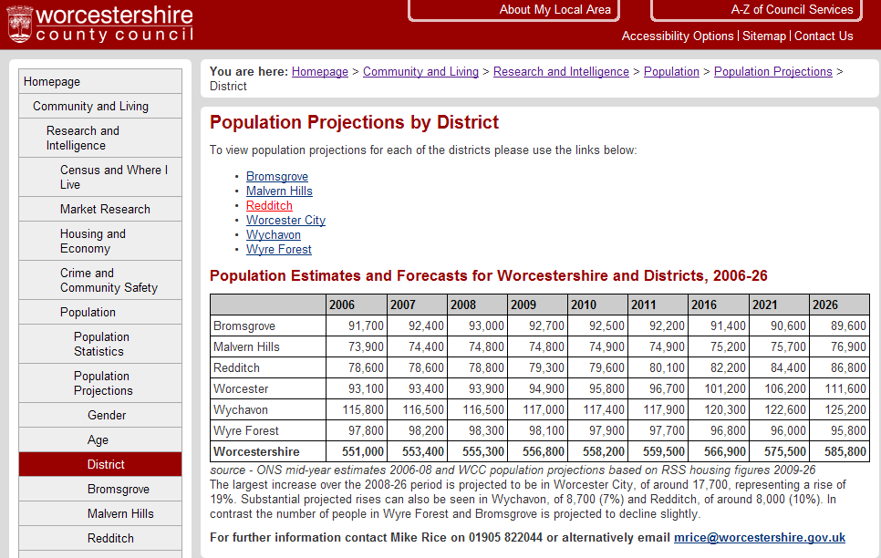
Table 1
The WCC population projections are well out of date and must be considered suspect. They are certainly at major odds with the ONS projections published in 2006 which are shown in Table 2. The WCC predicts that from 2010 – 2026 the populations of Bromsgrove and Wyre Forest will fall. This is such an apparently preposterous assumption that one has to joke: Maybe the planners have in mind to restore the 'Highland clearance' policy to the Lickey hills? Or perhaps a potato famine is predicted for Kidderminster resulting in mass emigration to the US?

 | 2006-Based Subnational Population Projections ONS
AREA NAME | 2006 | 2007 | 2008 | 2009 | 2010 | 2011 | 2016 | 2021 | 2026
Bromsgrove | 91.6 | 92.4 | 93.2 | 94.0 | 94.8 | 95.6 | 99.6 | 103.9 | 107.9
Malvern Hills | 73.9 | 74.2 | 74.6 | 75.0 | 75.4 | 75.7 | 77.7 | 80.1 | 82.6
Redditch | 79.5 | 79.7 | 80.1 | 80.4 | 80.8 | 81.1 | 83.2 | 85.4 | 87.3
Worcester | 93.4 | 93.6 | 93.8 | 94.1 | 94.4 | 94.8 | 96.6 | 98.4 | 100.2
Wychavon | 116.3 | 117.2 | 118.0 | 118.9 | 119.8 | 120.6 | 124.9 | 129.2 | 133.3
Wyre Forest | 98.2 | 98.6 | 98.9 | 99.3 | 99.7 | 100.2 | 102.4 | 104.8 | 107.0
Worcestershire | 552.9 | 555.6 | 558.6 | 561.7 | 564.8 | 568.0 | 584.4 | 601.9 | 618.4
Table 2

From Table 2 (above), it can be seen that the ONS predicted a population increase from 2006 – 2026 (20 years) for North and South Worcestershire, as follows;

South Worcestershire 32,500 North Worcestershire 32,900

For the 2010-2026 (16 year) period the figures are as follows;

South Worcestershire 26,500 North Worcestershire 26,900

Therefore, at the time of the creation of the RSS Option 2, both North and South Worcestershire populations were expected to grow in a similar way.

Why therefore was South Worcestershire required to build twice as many new houses as North Worcestershire in the RSS?

The RSS Option 2 demanded that Worcestershire as a whole build 36,600 additional houses in the period 2006 to 2026. Meetings held at the West Midlands Regional Assembly (WMRA) decided that South Worcestershire would build 24,500 new houses while North Worcestershire had to build just 12,100. (It is understood that no representative from either Malvern Hills or Wychavon district councils was present at this crucial meeting)

What might have been the root cause of this difference which appears totally unsupported by ONS population growth evidence?

In a letter from WCC of 6th June 2006 to the Government Office of the West Midlands the promotion of Worcester City to be a 'Sub Regional Foci' (i.e. a growth point) was signed by those shown in table 3;
Table 3
Yet it is our understanding, from correspondence received from the Chief Executives of the local authorities concerned, that at no time was any formal vote taken, in support of this growth status for Worcester, by any of the elected members of the authorities involved.

As Worcester City was not able to fulfil the obligation to accommodate substantial growth without utilising land from neighbouring authorities, it is considered wholly undemocratic (and possibly ‘ultra vires’) to continue to impose this arrangement upon the citizens of the neighbouring authorities without the democrat vote of their representatives being sought.

It is high time for this hole in the corner decision to be re-visited.

South Worcestershire Development Plan

With the demise of the RSS, coupled with a major economic downturn, we must now look to the future which starts in 2010 not 2006. The key to any increase in housing stock lies with the ability of the economy to generate additional jobs coupled with policies that attract new business ventures to the region. People have to be able to afford to buy as well as rent new houses.

On May 27th 2010 the ONS published a revision of the 'Sub-National Population Projections'. “Table 2d: Local authorities and higher administrative areas within England” provides population projections by local authority. Population growth figures currently published on the WCC web site are entirely at odds with this latest ONS data shown in Table 4 (below).

Table 4

In Table 5 (below) the details have been extracted from Table 4 to show the forecast population increase between 2010 and 2026 for both North and South Worcestershire.

Table 5

It is clear that both North and South Worcestershire have similar populations and are predicted to grow by about the same amount. The projected increase in population has reduced sharply in response to the poor economic climate resulting in a reduction of urban migration (few risk moving if their job is threatened) and the anticipated reduction in immigration to the UK.

The ONS “Table 15A Appendix 1: Household characteristics of quintile groups of all households: The effects of taxes and benefits on household income, 2005/06” provides the latest data available on average household numbers, which stood at 2.4 in 2006. This figure had varied little in the preceding period. So, if the average household in Britain comprises 2.4 people, based on the population growth forecasts in table 4 (above) of 18,800 for South Worcestershire and 18,800 for North Worcestershire, this calculates as a requirement for only 7830 new homes in the south and 7830 new houses in the north.

These figures demand that the housing numbers allocated for South Worcestershire be urgently re-visited. The distortion caused by the wholly undemocratic application to promote Worcester City as a 'Growth point' must be removed.

The Worcester County Council's LPT3 consultation

This current consultation exercise further illustrates a total lack of current data and it provides no vision. At no point is there even a list of the current deficiencies of Worcestershire’s transport network and nor is there any accommodation for electric vehicles. The population projections used in the guiding report; “TEMPRO Planning Data Version 5.4 Guidance Note” continues to use the ONS population projection for 2004. Is it too much to expect up to date information to be used?

We have yet to achieve a level of 21st century transport infrastructure in this region that will attract the calibre of inward employment we need. Therefore the employment area and housing cited should be that of Tewksbury where the example of promoting commercial activities adjacent to both sides of the M5 has to be followed. Only then will we attract employers of sufficient standing that they can pay good enough salaries to facilitate the purchase of homes by their employees.

Conclusion

It is hard to dismiss the possibility that the data published by the local authorities during the RSS review period was gerrymandered to support a political position. Even today that continues and it is high time both planners and elected members recognized that this position is no longer supportable. ‘Localism’ now rules and thus local evidence and local opinion should be respected and incorporated into planning.

