Wyre Piddle Parish Council

Minutes of a Meeting of the Council held on

28 January 2010
In the Village Hall, Wyre Piddle
Meeting commenced: 7.30 pm. Meeting ended: 8.20 pm.
Present: Cllrs S Turner (Chairman) C Turner, Cllr G Smout, J Morgan
In attendance: D M Taverner Parish Clerk
1/1/10 Apologies Cllrs M Wilkins, Cllr J Wilkins, County Cllr L Tucker
2/1/10 Declarations of Interest for a) the Meeting and b) Any Changes to be notified to the Registers of Interests and Gifts & Hospitality

None were declared as specific to this meeting

3/1/10 Closure of the Meeting to allow Parishioners Present to Speak on any Matter on the Agenda. The maximum time allowed per individual and other parochial matters for discussion to be at the discretion of the chairman. Questions which required a particular response to be submitted in writing.

Complaints were received from residents regarding incidents of dog fouling in Smith’s Meadow. The Clerk replied that signs were being purchased to be displayed at the entrances to the Meadow reminding dog owners that their pets should be kept under control and that dog mess should be cleared appropriately.

The Environmental protection team at Wychavon could only take action against dog owners if they received clear evidence against the dog owners responsible. A total ban on dogs accessing the Meadow would be impossible to monitor.

Further complaints were received regarding incidents of unauthorised vehicles crossing the Eastern Bridge. The Council had made it clear to Jon Fraser the Senior Highways Engineer of Worcestershire County Council who had attended the previous meeting that it expected prosecutions to be made against those drivers who were ignoring the red traffic lights. Under no circumstances was the bridge to be re-opened to all traffic.

4/1/10 To receive the Report of the County Councillor.

Cllr Tucker had sent her apologies for being unable to attend the meeting but had submitted the following written report which was read out to the meeting by the Clerk:-

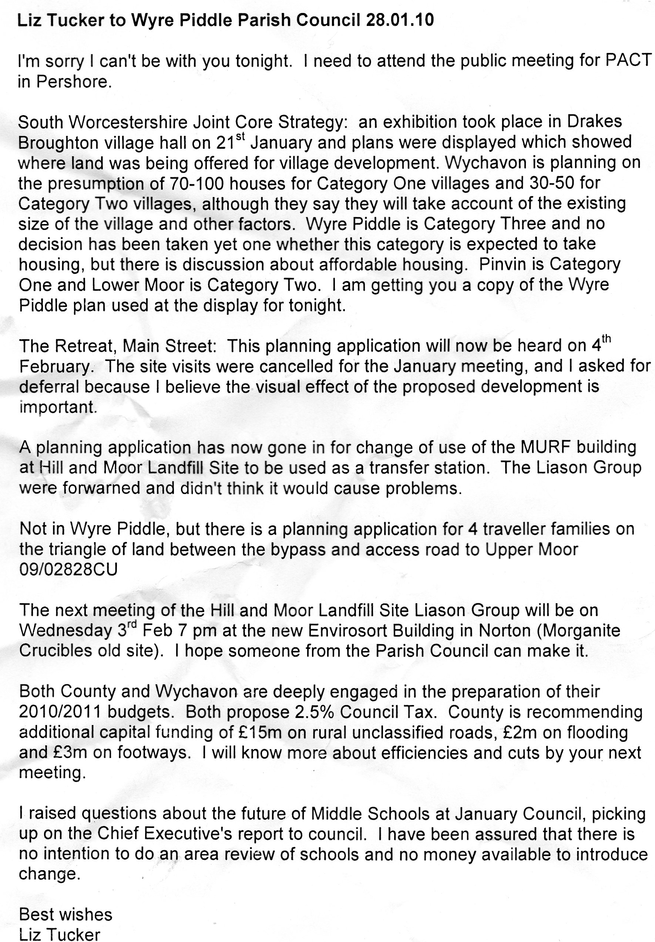

5/1/10 Minutes of last meeting
The minutes of the meeting held on 26 November 2009 had been previously circulated for approval by Members. No amendments were necessary and after being put to the vote it was resolved that the minutes be approved and signed by the Chairman as a correct record.

6/1/10 Planning:

The following application had been put before Members for consideration
The Retreat, Main Road, Wyre Piddle, Pershore, WR10 2JB
Third Storey extension Road Level to riverside
The Council had sent a strong letter of opposition to this application strongly opposed to this application as they felt that the proposed development would be totally out of character with the immediate built environment.

The completed building would greatly detract from the natural views and light enjoyed by residents in the immediate vicinity.

Objections had also been received from residents neighbouring the property.

The District Council Planning Committee Members had made a site visit to the property but despite the objections made had given approval to the application.
7/1/10 Community Christmas Events
Cllr C Turner outlined details of various forthcoming events which were to include a valentine’s Dance at Piddel House

8/1/10 Smiths Meadow Fencing Repairs and Signage

The Clerk reported that signage was being ordered to remind dog owners of their responsibilities for keeping their pets under close control when walking them in the Meadow. Signs would also be purchased to remind dog owners of their responsibility to clear dog mess.

9/1/10 Finance
(a)Payments The following accounts were authorised for payment:-
G Robinson £342.30 – for Lengthsman works
New Farm Grounds Maintenance £40.25 - Clearance of fallen willow Tree Branches
N Power –£141.01 Street Lighting – October to December 2009

10/11/10 Maintenance of open spaces
Lengthsman Scheme – Gary Robinson had been undertaking additional works under the scheme and the Clerk had agreed reimbursement arrangements with the County Council. It was agreed a Community litter pick event would be held in the late spring/ early summer

Maintenance of footpaths and hedgerows – the Clerk advised that he would be arranging a meeting with the relevant officers at the County Council to discuss the state of roadways and footpaths throughout the

The District Council had taken recent enforcement action against landowners in Mill Lane reminding them of their responsibilities for keeping drainage ditches clear and had reported that all the landowners approached had taken appropriate action.

11/11/10 Grass Cutting Contract 2010

The Clerk reported that the 2010 Grass Cutting Contract was now due for renewal. The current contractors New Farm Grounds Maintenance had indicated their willingness to continue with only a small inflation increase on their current prices. In view of the high quality of work that they had undertaken in the previous year Councillors were unanimous in deciding to continue with New Farm Grounds Maintenance as the grass cutting contactors during 2010

There being no other business the Chairman closed the meeting at 8 20pm

Date of next meeting Parish Council meeting 25 March 2010
Approved …………………………………. Chairman 25 March 2010

