Minutes of the Parish Council Meeting held in Lower Moor Parish Rooms on

Thursday, 5th January 2012.

Present: Cllrs Butler, Cllr Hayes, Cllr Bell, Cllr Selvey, Cllr Bruce, Cllr Buckley & Cllr Morgan-Nash.

In attendance: Clerk, CC Tucker & members of the public

- Apologies. CC Tucker apologised for being late

- Declarations of Interest
- Register of Interest: Councilors were reminded to update the register of Interest.
- Personal Interests: Cllr Bruce for planning application W/11/02292/PN
- Prejudicial Interests: None

- Minutes: The minutes of the meeting held on 3rd November 2011 were accepted and signed

The meeting opened at 7.30pm, closed at 7.35pm for public time and reopened at 7.50pm

      - Progress report
- Lengthsman
Reports of a blocked gully near Hill House in Hill. ME to advise Nick Winter

- Flood / Drainage
Clerk to send proposal to Ringway, Laser and Halcrow for quotations. NB to send ME proposal

- Village Post Office & Post box
Still waiting for the post box to be repositioned. Letter been sent in regards to liability of accident

- PACT News
Update from 13.9.11 meeting:
(a) Liz Tucker informed us that County Hall had decided to install a swing arm type barrier on the railway bridge at Wyre Piddle. The chairman also mentioned that the local policing team would be reporting any driver going through the red lights for driving without due care and attention in the meantime.
(b) Liz Tucker informed the meeting that the final approval had been given for the new roundabout on the A44 adjacent to the greenhouse complex.

- The Chairman then read a report from CSO Simon Hall on the issues he felt were important. A copy is attached.

- There was then a detailed discussion on the installation of Vehicle Activated Speed Signs (VASS) in the three parishes of Bishampton, Pinvin and Wyre Piddle (Hill and Moor having opted out at this stage).

- Further calls were made by the chairman to encourage more residents to join the panel. The chairman proposed that he would attend Parish Council meetings in the New Year to this end. The chairman also stated how important it is to have a strong and active panel, particularly as changes may be afoot in the consultation process adopted by West Mercia Police in the future. He read a section of a reply from the Chief Constable to a question on the future of PACT posed at a recent webcast.

- Under any other business the issue of Smart Water was discussed and it was decided that the panel should give its support to promoting the product wherever possible, including parents' evening at the school. MH to get a price on Smart Water

- The new Police non-emergency number (101) was mentioned and, again it was proposed that the panel should promote this at every opportunity.

- There was concern expressed at the reducing amount of communication from the Police to communities when incidents had occurred. It was felt that if groups such as Neighborhood Watch and PACT were going to help the Police in their efforts to reduce crime, then there needed to be a much better flow of information about crimes or attempted crimes in the neighborhood. Much of the information currently received is coming via the “grape vine” and is often too late to be of much use.

- Parking on pavements was still an issue in all the communities particularly outside the school in Pinvin.

The next meeting was scheduled for the second half of March 2012 at the Lower Moor Village Hall. The chairman will contact the person responsible for bookings at the hall to get a date that suits all.

- Lighting
It was agreed to go ahead with the lighting project in this financial year, excluding Eco lights.

- Footpaths
- Bogs Lane Style has been replaced however it is not suitable for elderly to cross. ME and JB to walk the path and check it out.

- Simms & Woods site / Sandfields Farms Ltd
Planning permission has been refused by Wychavon on the following grounds:-

Saved Policy GD1 of the Wychavon District Local Plan (adopted 2006) seeks to resist new development in areas outside of defined settlements unless it accords with a specific policy in the Local Plan. The application site falls well outside of a defined settlement and is located in the open countryside. The proposed development seeks temporary residential accommodation in association with an existing commercial business. The proposal is considered large scale and would not relate to essential rural workers accommodation. Whilst acknowledging that the existing business processes, packages and distributes agricultural produce, this is not an agricultural operation. The proposed residential accommodation is therefore desirable (on good business acumen grounds) rather than on an essential
Agricultural need. Having considered the applicants case for 'economic development' benefits, the Local Planning Authority, having regard to the scale and location of the
proposed development raise objection on the grounds of sustainability and encroachment into the open countryside. The application therefore fails to comply with the adopted Local Plan Policy GD1; Worcestershire County Structure Plan Policies D10 & D17 as well as guidance contained in PPS4 (Planning for Sustainable
Growth).

- Jubilee
Nothing to report

- New items
  - Notice board
Clerk has a printed A3 size map for the notice board. Chairman to hand over a key for the board to the Clerk

  - Dog bins
Cost to provide extra dog waste bins on the Playing Field start from £90.24 up to £251.64. It was agreed to purchase3 25l green bins. Decision needs to be made as to the siting of the bins & possibly getting agreement from neighbors’. Action JB

  - Budget /Precept
It was agreed not to increase the Precept. The Budget was unanimously approved.

  - Broadband
The Council needs to make residents aware of the Broadband survey taking place.

  - Statistics Crime Figures
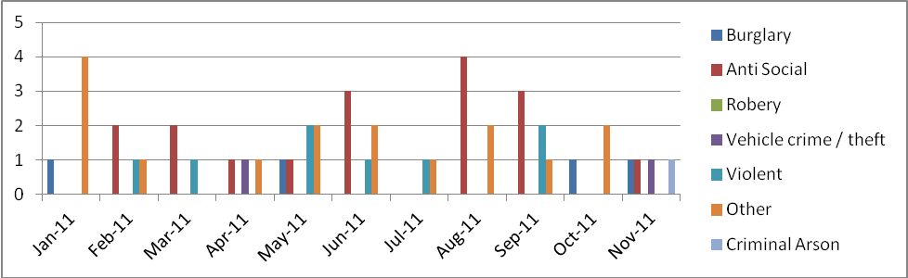
Per month
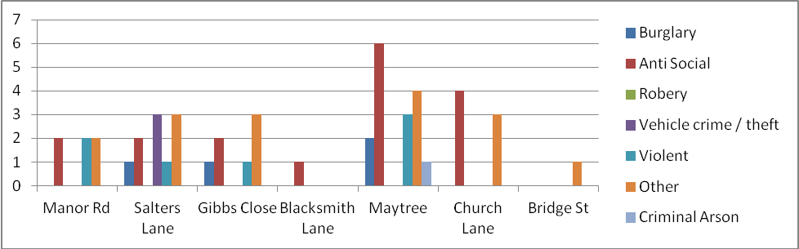
Per street

- Planning:
- Council’s response to planning applications between meetings and reports on decisions
- Current planning applications
W/11/02563/PN Dalamere Hill Furze
Proposal: - Demolition of existing semi detached dwelling and replacement with new build detached welling to include double garage, amendment to PA W/11/01318/PN. Reduction in ridge height of proposed garage – It was unanimously agreed that the garage would be too close to the road and the log store is over the building line

W/11/02669/PP The Finches, Bridge St, Lower Moor
Proposal :- Construction of timber double garage.

W/11/02606/PN Fir Tree Cottage, Blacksmiths Lane, Lower Moor
Proposal :- Erection of a new 3 bed detached bungalow. The PC to compare the current plans to the original application. Action NB/LT

W/11/02292/PN Recreation Ground Lower Moor
Proposal :- Erection of a 14 “Engelswies Play Unit
The PC has agreed to move the equipment to the side of the present playground.

W/11/02484/CW Evesham Rd, Lower Moor
Proposal :- Change of use of agricultural land to equestrian use. Land at, Evesham Road, Lower Moor Mr E Luker - The PC object to this application

- Finance:
- Payments made between meetings per attached list
Date | Cheque No | Payee | Amount | Item
03-Nov | 633 | N Butler | £ 128.94 | Mowing expenses
10-Dec | 634 | GBD | £ 76.38 | mowing
10-Dec | 635 | N Winter | £ 264.10 | Lengthsman
10-Dec | 636 | M English | £ 28.83 | Mileage
 |  |  | £ 7.82 | stationery
 |  |  | £ 68.70 | Overtime / studies
 |  |  | £ 17.50 | Expenses
 |  |  | £ 274.79 | wages
 |  |  | £ 867.06

To approve cheques for payment
Date | Cheque No | Payee | Amount | Item
05-Jan | 637 | N Winter | £ 309.15 | Lengthsman
05-Jan | 638 | M English | £ 36.79 | PC World - ink
 |  |  | £ 14.72 | Overtime / studies
 |  |  | £ 12.31 | Mileage
 |  |  | £ 17.50 | Expenses
 |  |  | £ 274.79 | wages
 |  |  | £ 665.26

- To note any receipts and approve invoices for payment
N/A
- To approve the statement of cash reconciliation for October 2011

The current account opened with a balance of £8,569.79

Cheques to the value of £738.12 were written out, £340.48 is still to be presented to the bank.

This left a closing balance of £8,172.15 in the current account.

The savings account opened with £15,258.62 received £0.63 interest, giving a closing balance of £15,259.25

As at December 31st 2011 the cash assets for the PC stand at £23,090.92

- To approve claims for expenses/overtime
Overtime and expenses to the value of £81.32

- Councilors’ reports and items for future agenda
News letter
Contract of employment for the Clerk
Bonus scheme for homes
Dog bins

- County and district councillor report.
CC Tucker spoke on the outcome of the Sandfields Farm Planning Application.

- Clerks report on Urgent Decisions since last meeting.

- Correspondence for information: To note the attached appendix of items which have been circulated or will be available for inspection at the meeting
- Budget consultation briefing Wed 18th Jan ‘ 6.30pm at County Hall. Book places by 13/1/12 to democraticservices@worcestershire.gov.uk. Two Cllrs wish to attend Action AMN/NB

- New Bonus Homes Scheme
For new or empty homes occupied between 1 October 2010 and 30 September 2011, the Government is giving us an annual New Homes Bonus payment of £437,941 for six years.

For parishes with housing growth, we have allocated 40% of our New Homes Bonus for reinvestment in local communities where the development that generated it has taken place.

To find out whether your area has generated any New Homes Bonus go to www.wychavon.gov.uk/newhomesbonus and click on the name of your parish/town. The amount allocated for reinvestment in your parish is shown in cell D10 of the spreadsheet.

H&M has been allocated £1,688.00

We invite parish and town councils to submit proposals for spending the New Homes Bonus allocations for their area on projects or activities that deliver added value to the local community, and where possible, benefit communities close to any development that the Bonus is associated with.

Cinema Screen in the village hall, Orchard and the provision of Cricket nets were among the ideas for discussion at the next meeting.

- To affirm the dates of the next meeting of the Parish Council.
The next meeting was confirmed for February 2nd 2012 at the Village Hall, Lower Moor
The meeting closed at 10h30
………………………………………………..(chairman)

……………………………………………..(date)
M English - Mrs – Clerk
PUBLIC NOTES

Four members of the public attended the meeting to discuss the following.
Mr. & Mrs. Rose strongly objected to any new playground equipment be erected. They raised their concerns over teenagers using the play area in the evenings as well as bad language.
Mr. Mike Haines had no objection is the new proposed equipment however objected it being sited in front of his home. He suggested the PC move the equipment to the side of the present playground.
It was mentioned that the bonfire site had not been reseeded.
All of the above were noted and the Chairman thanked the members of the public for attending.

