Parish Council of Alfrick and Lulsley
Members are summoned to a Meeting of the Parish Council on Tuesday 21st April 2009 at 7.30pm in the Village Hall, Alfrick.

Public Question Time prior to the formal meeting;
Members of the public may wish to raise matters of concern prior to the formal meeting.

AGENDA
- Members' Apologies for absence
- Members' Declarations of Interest.
- Reports; County & District Councillors, Parish Footpaths' Warden. Parish Tree Warden.
- Confirm the minutes of the meeting held on 17th March 2009 circulated in advance.
- Financial Matters;
- Approve - Annual Accounts for 2008-9, Draft circulated in advance.
- Approve payment, Clerk's expenses for January-March 2009, £121.88
- Review Risk Assessment for 2009-10, note 2008-09 assessment circulated in advance.
- Planning Matters; Consider a response to application; 09/00432/FUL Two-storey extension - Whistlewood Cottage, Lulsley
- Approve Spring Newsletter - circulated in advance.
- Report; Sphere Taxi/Bus project; Cllr C Williams
- Report; The informal group on Housing and Planning matters. - Cllr R Jackson
- Clerk's Report - Correspondence & Publications Received - circulated in advance
- Confirm arrangements for the Annual Parish Meeting 12th May 2009 at 7.30pm in the Village Hall.
- Items for the next meeting.
- Confirm the date of the next meeting; - Annual Meeting of the Council, May 19th 2009
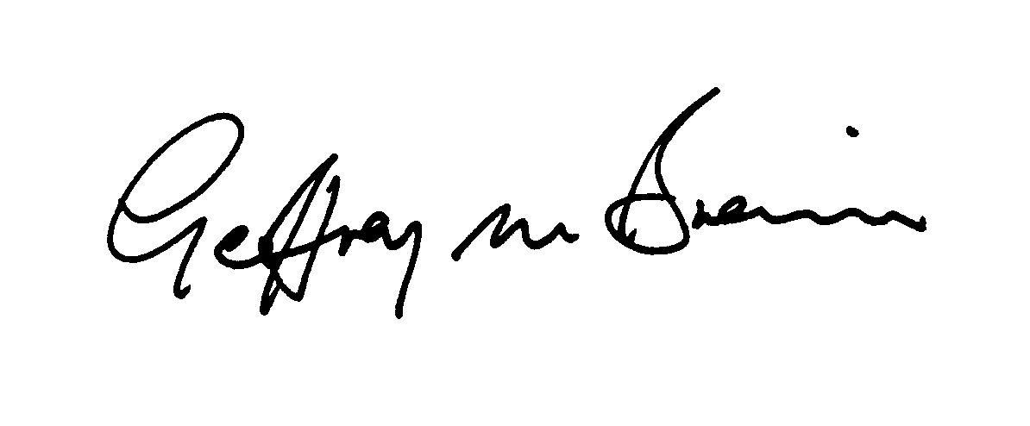13/04/2009

