DRAFT Minutes of the Extra-Ordinary Meeting of the Parish Council held on
June 26th 2018 at 7:30pm at Rous Lench Village Hall

Present | Chairman Cllr D Browne, Vice-Chairman Cllr G White, Cllr C Dudley, Cllr G Hughes,  Cllr J Davis, Cllr D Wicks, Cllr L Newton  In attendance: Temporary Clerk, 0 members of the public.  Meeting opened at 7:30pm

There was no public question time, due to no members of public being in attendance.

195/18 | Apologies: none

196/18 | Declarations of Interest: None declared. Councillors were reminded of the need to update their register of interests.

197/18 | Dispensations: no requests received.

198/18 | Vice-Chairman to sign Declaration of Acceptance of Office. Cllr White had been elected to the post of Vice-Chairman in his absence at Annual Meeting of the Parish Council. Cllr White signed his declaration and was witnessed by Clerk.

199/18  a.  b.  c. | Progress Reports - Clerk Reported  End of Year Accounts for 2017/18 completed. Internal audit completed.  Governance documentation must be published onto website by 2nd July 2018.  Receipt received in relation to payment for petrol to lawnmower.  Response sent to resident raising queries in relation to grass verge, railings, cyclists etc.  Temporary Clerk attended the GDPR training on 12th June – a presentation of slides to be circulated to Councillors for discussion at July PC Meeting.  To meet NALC recommendations the PC agreed in May to register with ICO (Information Commissioners Office). However, registration has increased to £40. Therefore an additional £5 cheque has been prepared. Financial Summary presented as below:-  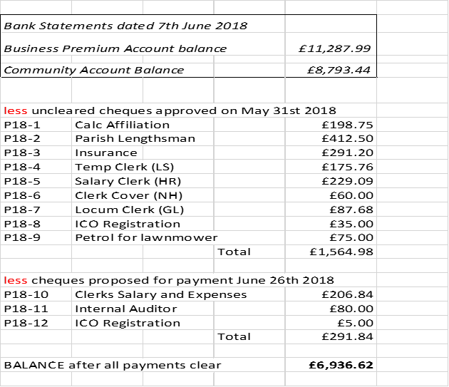
200/18 | Finance: Clerk presented the Year End Finance and Governance for approval as follows:  - Internal Audit Report had been completed and duly signed by Auditor.  - The Council approved the Annual Governance Statement 2017/18.  - The Council approved the Accounting Statements 2017/18.  - The Council approved the Schedule of Fixed Assets 2017/18.  - The Council approved the proposed dates for the Exercise of Public Rights.  - Clerk presented payments as per item 199/18 c. Payments approved.  - The Council approved the Certificate of Exemption 2017/18.  Action: All items to be published by Clerk to website by 2/7/2018 deadline.

201/18 | Correspondence –  - Application for Grant for WW1 project. Clerk to request further details of the format, content and size of the leaflet. Action: To be included on July agenda.  - NHBS – Clerk presented a letter from Wychavon that has been circulated to all Councils outlining the protocol for successful applications. Action: To be included on July agenda.  - NHBS event on 5th July at Civic Centre, Pershore. Open to Councillors to understand the changes to the NHBS system. Action: Clerk to advise Chair of the timing of event.  - Crime Prevention Workshop – West Mercia Police are running an event on July 6th 2018 – 10am-1pm. Action: Notices to be pinned to noticeboards.

202/18 | Councillors Reports & Items for Future Agenda –  - It was reported that the lime trees on the village green have branches that are growing low. Also, some old branches from the Oak Tree are becoming a hazard.  Action: Clerk to write to J. Whitfield to request an inspection and to provide a report. Council will seek tenders for the remedial work necessary.  - It was reported that parishioners have commented that the canopy over old well is rotting and has become unstable. Action: Clerk to write to property owners.  - It was reported that the post box has tiles that are coming away and considerable growth of ivy which needs attention. Action: Clerk to write to property owners.  - Clerk was asked to check whether the Council is at full quota of Councillors or if there are any vacancies. Action: Clerk to check.  - Shortly after turning onto Radford Road from the Wheelbarrow Castle junction t there are overhanging branches which need to be cut back. A fallen branch has been put into the ditch. Action: Clerk to report to Highways Dept.  - Clerk/SSP. Action: To be put onto July agenda.  - Neighbourhood Plan to be discussed. Action: To be put onto July agenda.

203/18 | Date of next meeting: there will be an Ordinary Meeting of the Parish Council held on July 16th 2018 at 7:30pm, to be held at the Village Hall.

Meeting closed at 8:35pm

SIGNED………………………………………. Chairman
Date ………………………………

