A G E N D A  for a MEETING of  THE PLANNING COMMITTEE  of  CHADDESLEY CORBETT PARISH COUNCIL  To be held on  Monday 5 January 2009  at Chaddesley Corbett Village Hall  after the conclusion of the Parish Council meeting | 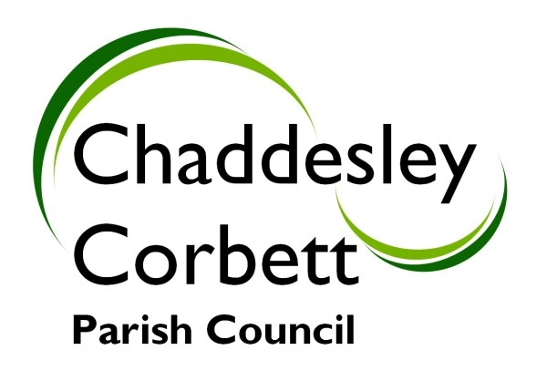
1. Apologies

2. Declarations of Interest
a) Personal Interest
b) Prejudicial Interest

The meeting will now adjourn for Public Question Time.

Meeting will Re-Open

3. Minutes for approval: Minutes of meeting on 1 December 2008

4. Progress Reports:

5. Correspondence/other information received:

6. Previous Planning Applications Approved/Rejected:
08/1013/HEDGE – Tanwood Lane – Removal of hedgerow does not contravene any legislation.

08/0944/FULL – Brockencote Hall – Extension to kitchen and store. Approved.

7. Planning Applications for Consideration:
7.1 08/1051/FULL – Holly Cottage, Brockencote – Two storey side extension to accommodate elderly parents.

7.2 08/1070/FULL – 5 Morton Road, Harvington – Double car port/garage with pitched roof.

Any new applications.

Date of next meeting: Monday 2 February 2009

Signed……………………………….. (Clerk)

