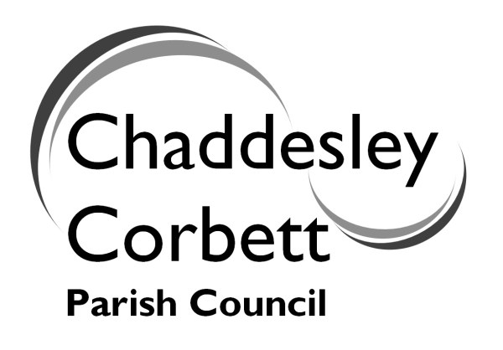 | ANNUAL PARISH MEETING  on  Monday 21 May 2012  at  7.00 for 7.30 p.m.  at  Chaddesley Corbett Village Hall
Refreshments from 7.00-7.30p.m.

AGENDA FOR MEETING

7.30 1. Welcome and Introductions Cllr Jonathan Swift

7.35 2. Police PC Andy Willetts

7.45 3. Neighbourhood Plan Cllr Jonathan Swift

8.00 4. Emergency Planning Cllr J Swift

8.15 5. Queen’s Jubilee Celebrations Cllr Jonathan Swift

8.30 6. New School Colin Emeny – Chairman of Governors

8.45 7. Environmental Group Martin Kenrick

8.55 8. Lengthsman Scheme Cllr Bob Green

9.00 9. Community Bus Service Robert Hartell

9.10 10. Parish Footpaths Alan Kingston

9.25 11. Open Session

