A G E N D A  for a MEETING of  THE PLANNING COMMITTEE  of  CHADDESLEY CORBETT PARISH COUNCIL  To be held on  Tuesday 3 January 2012  at Chaddesley Corbett Village Hall  after the conclusion of the Parish Council meeting | 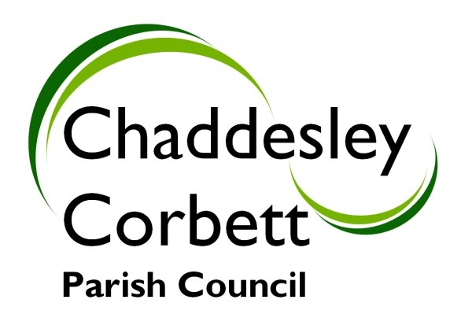
1. Apologies

2. Declarations of Interest
a) Personal Interest
b) Prejudicial Interest

The meeting will now adjourn for Public Question Time.

Meeting will Re-Open

3. Minutes for approval: Minutes of meeting of 5 December 2011

4. Progress Reports:
4.1 Robin Hood – Appeal dismissed on enforcement notice to demolish and remove building from land.

5. Correspondence/other information received:

6. Previous Planning Applications Approved/Rejected:
6.1 11/0172/LIST – Installation of lightweight glass and steel draught lobby at Harvington Hall – Approved.

6.2 11/0594/FULL – Proposed alterations to include rooflights, conversion of roof space to form en-suite, window alterations and internal reconfiguration at Vicarage Farm, Fold Lane, Chaddesley Corbett – Approved.

6.3 11/0644/FULL – Demolition of existing garages and construction of four affordable houses on land adjacent to the Green, Chaddesley Corbett.

7. New Planning Applications.
7.1 11/0706/FULL – Robin Hood Pub, Drayton – Layout and provision of replacement children’s play equipment and fencing (Retrospective application)

7.2 11/0725/LIST – 1 to 5 Alms Houses, Brockencote, Chaddesley Corbett.
Repair, insulate and re-cover roofs (pitched and flat), insulate outbuilding cavity walls, replace entrance doors, double glaze/secondary glaze existing windows, re-furbish kitchens and bathrooms, add ventilation to kitchen and bathrooms, upgrade heat.

Any new applications. Date of next meeting Monday 6 February 2012.

Signed……………………………….. (Clerk)

