Councillors are Invited to  a MEETING of  CHADDESLEY CORBETT PARISH COUNCIL  To be held on  Monday 1 September 2008  At 7.30 p.m.  at Chaddesley Corbett Village Hall | 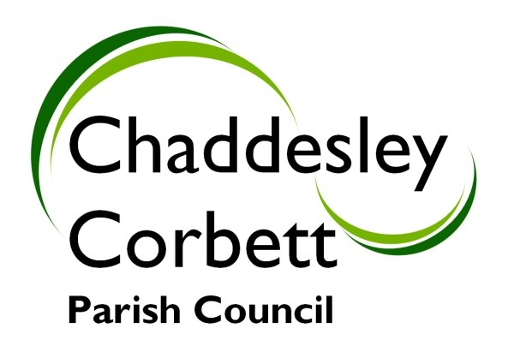
A G E N D A
7.25 ATTENDANCE BY POLICE.

7.30 1. APOLOGIES

2. Declarations of Interest
a. Declarations of Personal interest
b. Declarations of Prejudicial Interest

The meeting will now be adjourned for PUBLIC QUESTION TIME

7.35 The meeting re-opens
3. Minutes
a) Minutes of meeting held on 7 July 2008
b) Formal acceptance of Minutes of the Planning Committee meeting held on 7 July 2008

7.40 4. Progress Reports
4.1 Update Report from Clerk on matters arising during summer recess.

7.45 5 Consultation Documents/Meetings:
5.1 Rural developments Programme – Money for community projects. Meeting Friday 19 September at 9.30-4.00 Bank House Hotel, Bransford, Worcs WR6 5JD. Cllr D Thomas has agreed to attend. Further representatives requested (clerk on holiday).

5.2 Parish Forum – Tuesday 21 October at 6.00 Duke House, Kidderminster. Any suggested comments.

5.3 Bromsgrove Town Centre Area Action Plan – Consultation document.

7.50 6. Bus Service

7.55 7. Education Foundation Trust – Trust Deed indicates 3 Parish Council Representative Governors should be appointed.

8.00 8. Chaddesley Corbett Football Club – Request for funding.

8.10 9. Proposed Post Office Closures – Report from Cllr G Vernon

8.15 10. Harvington Hall Lane – Traffic Census.

8.20 11. Review of burial fees and charges

8.25 12. Update report on proposed car park

8.30 13. Margaret Delabare Charity – Accounts year ended December 2007.

8.35 14. Land at the rear of the Hemmingway.

8.35 15. Reports from Councillors Representing Outside Bodies
15.1 Village Hall
15.2 Chaddesley Corbett First Endowed School
15.3 Charity Trusts
15.4 Wyre Forest Area Calc
15.5 Police Community Engagement Group

8.40 16. Worcestershire County Association of Local Councils

8.45 17. Allotments - Report from Cllr L Stockford

8.50 18. Burial Ground - Report from Cllr K Bartlett

8.55 19. Lengthsman Scheme - Report from Cllr G Vernon

9.00 20. Financial Report
20.1 Audit Closure
20.2 Bank Reconciliation at 30 June 2008
20.3 Receipts and Payments
20.3 Current bank balances

9.05 20. New Highways Issues and Items for next meeting.

Dates for your diary: Next Meeting 6 October 2008:

Signed………………………………………………. Clerk

