A G E N D A  for a MEETING of  THE PLANNING COMMITTEE  of  CHADDESLEY CORBETT PARISH COUNCIL  To be held on  Monday 3 November 2008  at Chaddesley Corbett Village Hall  after the conclusion of the Parish Council meeting | 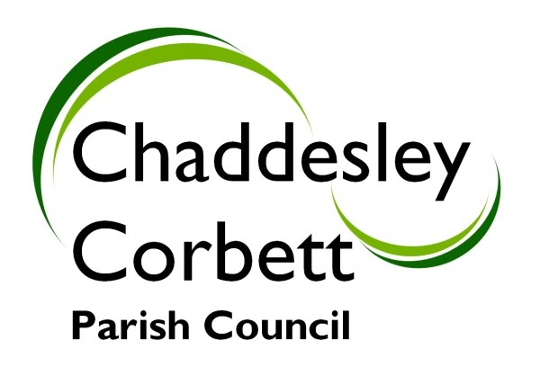
1. Apologies

2. Declarations of Interest
a) Personal Interest
b) Prejudicial Interest

The meeting will now adjourn for Public Question Time.

Meeting will Re-Open

3. Minutes for approval: Minutes of meeting on 6 October 2008

4. Progress Reports:
4.1 Woodlands – new vehicular access – letter from Wyre Forest District Council.

4.2 Advertising Signs – Communities and Local Government Publications Guidance Notes.

5. Correspondence/other information received:

6. Previous Planning Applications Approved/Rejected:
6.1 08/0845/LIST – Brook Cottage – Conservatory - Variation to Consent 08/0302 – Garden Wall.
6.2 08/0750/TREE – Consent to crown lift of one holly tree

7. Planning Applications for Consideration:

None received at time of formulating the Agenda.

Any new applications.

Date of next meeting: Monday 1 December 2008

Signed……………………………….. (Clerk)

