A G E N D A  for a MEETING of  THE PLANNING COMMITTEE  of  CHADDESLEY CORBETT PARISH COUNCIL  To be held on  Monday 11 May 2009  at Chaddesley Corbett Village Hall  after the conclusion of the Parish Council meeting | 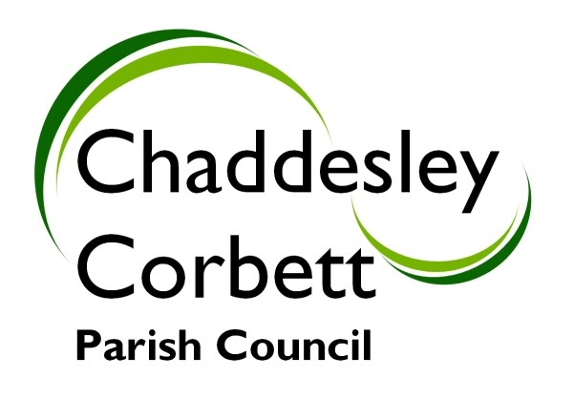
1. Apologies

2. Declarations of Interest
a) Personal Interest
b) Prejudicial Interest

The meeting will now adjourn for Public Question Time.

Meeting will Re-Open

3. Minutes for approval: Minutes of meeting on 6 April 2009

4. Progress Reports:

5. Correspondence/other information received:

6. Previous Planning Applications Approved/Rejected:

7. Planning Applications for Consideration:
7.1 09/0288/LIST – Wood burning stove with midtherm flue system, Tavy Barn, The Holloway.

7.2 09/0287/FULL – Installation of external flue in roof slope facing, Tavy Barn, The Holloway.

None advised at date of preparation of Agenda.

Any new applications.

Date of next meeting: Monday 11 May 2009

Signed……………………………….. (Clerk)

