Councillors are Invited to  a MEETING of  CHADDESLEY CORBETT PARISH COUNCIL  To be held on  Monday 1 June 2009  At 7.25 p.m.  at Chaddesley Corbett Village Hall | 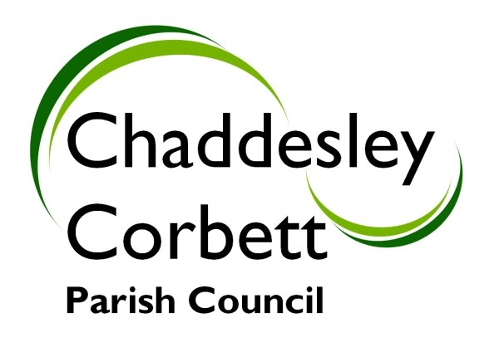
A G E N D A
7.25 POLICE.

7.30 1. APOLOGIES
2. Declarations of Interest
a. Declarations of Personal interest
b. Declarations of Prejudicial Interest

The meeting will now be adjourned for PUBLIC QUESTION TIME

7.35 The meeting re-opens
3. Minutes
a) Minutes of meeting held on 11 May 2009
b) Formal acceptance of Minutes of the Planning Committee meeting held on 11 May 2009
c) Minutes of Annual Parish Council Meeting held on 11 May 2009

7.40 4. Progress Reports
4.1 Report on attendance at CPRE Meeting 16 May – Cllr J Swift
4.2 Harvington – Conservation Sign – Cllr D Thomas
4.3 Equality and Human Rights – Passed to Alison Braithwaite – District Council
4.4 Parish Footpaths – Update – Clerk
4.5 Parish Council Insurance – Update – Clerk
4.6 The Green, Chaddesley Corbett – Use as a 5-a-side football pitch/rounders pitch/running track.
4.7 Training in Power of Well Being
4.8 Other ad-hoc update reports.

7.55 5 Consultation Documents/Meetings:
5.1 West Midlands Regional Business Crime Action Plan – Documents attached
5.2 Consultation on Possible Changes to the Administration of Concessionary Travel – Documents attached

Items for Decision/Discussion

8.00 6. Formal approval of Parish Council Accounts for the year ended March 2009. Risk Assessments and Declaration. Accounts as presented at meeting held on 11 May 2009.

8.10 7. Appointment of Trustees to Education Foundation – 4 year term of office.
Current nominations: Phyllis Pardoe, Hugh Richards, David Spencer.

8.15 8. Projector for hall in Village Hall. Microphone and speaker.

8.20 9. Proposals for a new web-site for the Parish Council

8.25 10. Minutes of Annual Parish Meeting and Annual Report to Parishioners.

8.35 11. Request for a contribution to the cost of resurfacing Fold Lane.

8.40 12. Chairmans Report

8.45 13. Reports from Councillors Representing Outside Bodies
13.1 Charity Trusts – Cllr S Williams
13.2 Wyre Forest Community Housing – Cllr G Vernon
13.3 Village Fete – Cllr J Fox

8.50 14. Allotments - Cllr L Stockford

8.55 15. Burial Ground – Cllr K Bartlett

9.00 16. Lengthsman Scheme and Highways- Cllr G Vernon

9.05 17. Financial Report
17.1 Receipts and Payments

9.10 18. New Highways Issues and Items for next meeting.

Dates for your diary: Next Meeting Monday 6 July at 7.25 p.m.

Signed………………………………………………. Clerk

