Councillors are Invited to  a MEETING of  CHADDESLEY CORBETT PARISH COUNCIL  To be held on  Monday 2 November 2009  At 7.25 p.m.  at Chaddesley Corbett Village Hall | 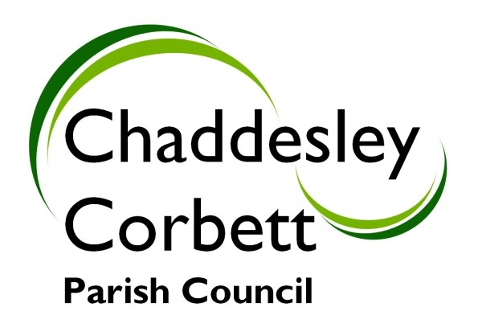
A G E N D A
7.25 POLICE.

7.30 1. APOLOGIES
2. Declarations of Interest
a. Declarations of Personal interest
b. Declarations of Prejudicial Interest

The meeting will now be adjourned for PUBLIC QUESTION TIME

7.35 The meeting re-opens

3. Minutes
a) Minutes of meeting held on 5 October 2009
b) Formal acceptance of Minutes of the Planning Committee meeting held on 5 October 2009

7.40 4. Progress Reports
4.1 County Councillor S J Clee – response to our letter of 8 September 2009 (if any)
4.2 Revision to proposed diversion of Footpath 578 (formerly footpath 42)
4.3 Correspondence between Keith Perkins Worcs CALC and Cllr J Swift.
4.4 Word on Worcestershire Magazine.
4.5 Update on parking in the village – the school.

7.45 5 Consultation Documents/Meetings:
5.1 Worcestershire County Council Parish Conference – Monday 16 November 2009 – Subjects Access to funding, local area agreement targets, Worcestershire Hub. 7.00 pm ?
5.2 Worcs CALC Annual General Meeting – Wednesday 25 November 2009 at County Hall – 6.30-7.00p.m.
5.3 Planning Training 12 November 2009
5.4 CPRE – 17 November 2009
5.5 Worcestershire Assembly 2009 – 5 November Worcester Racecourse 10.00-3.00 p.m.
5.6 Report from Cllr J Swift on attendance at Wyre Forest Matters Forum on 14 October.
5.7 Worcestershire Cultural Strategy 22 November 2009
5.8 Wyre Forest Area Calc Meeting 2 December Swan Inn, Chaddesley Corbett. 7.00
5.9 Meeting with District Council on affordable housing sites.

Items for Decision/Discussion

7.55 6. Adoption of the Power of Well Being.

8.00 7. Draft Residents Handbook

8.05 8. Conservation Area sign for Harvington.

8.10 9. Appointment of two Trustees to the Margaret Delabare Charity Trust. 4 years.

8.15 10. Community Orchard Fund Raising Event 11 November 2009.

8.20 11. Parish Forum – Report from Cllrs S Williams and M Bird.

8.25 12. Photocopier for the Parish.

8.30 13. Dates for Meetings – 2010

8.35 14. Chairmans Report

8.40 15. Reports from Councillors Representing Outside Bodies
15.1 Wyre Forest Community Housing – Cllr G Vernon
15.2 New School – Cllr Mrs P Pardoe
15.3 Police
15.4 Village Hall

8.45 16. Allotments - Cllr L Stockford

8.50 17. Lengthsman Scheme and Highways- Cllr G Vernon

8.55 18. Financial Report
18.1 Receipts and Payments

9.00 19. New Highways Issues and Items for next meeting.

Dates for your diary: Next Meeting Monday 7 December 2009

Signed………………………………………………. Clerk

