THE POWER OF WELL-BEING  COMMUNITY ENGAGEMENT  STATEMENT OF INTENT | 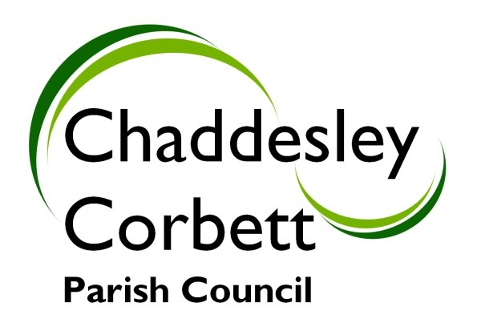

AIMS AND OBJECTIVES
Community Engagement is the process by which community organisations and individuals build ongoing permanent relationships for the purpose of applying a collective vision for the benefit of the community.

Chaddesley Corbett Parish Council aims to engage with all residents, voluntary groups and businesses in the Parish to consult and involve them in the decision making process and empowered action, in order to ensure consideration is made of the diversity that exists within the community.

This will involve:
- Informing the community of policy directions from government
- Consulting the community as part of a process to develop government policy, or build community awareness and understanding
- Involving the community to ensure that issues and concerns are understood and considered as part of the decision making process.
- Collaborating with the community by developing partnerships to formulate options and provide recommendations
- Empowering the community to make decisions and to implement and manage change.

DEFINING THE COMMUNITY
Chaddesley Corbett Parish Council will proactively engage with residents, voluntary groups and businesses within the Parish, District and County Councils and third sector partnerships.

PROVISION OF INFORMATION TO THE COMMUNITY
Chaddesley Corbett Parish Council will inform all sectors of the community of all their activities through the publication of Minutes of Meetings, Agenda for Meetings, Annual Reports, Newsletters, public notices, including consultation of Local Development Frameworks, Local Plan, Planning Applications, and all matters relating to the organisation, administration and finance of the Parish Council.

Information will be made available via:
- Parish Notice Boards
- Parish Magazine
- Newsletters
- Annual Reports
- Public Meetings
- Annual Parish Meetings
- Minutes of Parish Council Meetings
- Minutes of Planning Committee Meetings
- Parish Council Web-Site
- Worcestershire County Council Website

OPPORTUNITIES FOR COMMUNITY INVOLVEMENT
Agendas for meetings are published on Notice Boards 7 days before the meeting itemising all items for discussion or consideration.

Prior to each Parish Council meeting, residents have the opportunity during an Open Session to address Parish Councillors with their views, on any matter of concern.

Contact with the Clerk is available directly from the web-site and residents will be encouraged to enter into discussion forums.

Contact details for all eleven parish councillors is published in the Parish Magazine monthly, the Annual Report and Newsletters.

Where important issues have been identified, public meetings will be held inviting resident participation.

OPPORTUNITIES FOR FORMAL REPRESENTATIONS TO THE COUNCIL
Residents, community organisations and businesses are encouraged to send written representations to the clerk at least 10 days before the date of the next meeting. These representations will be included on the Agenda for the next meeting and copies sent to all Councillors. After formal discussion, the applicant will receive a written response of any decision or action taken by the Parish Council.

INVOLVEMENT IN PARTNERSHIPS
The Parish Council is actively involved in community organisations and activities and some Councillors are Trustees or Elected Members of those organisations. These include:
- Chaddesley Corbett Village Hall
- Wyre Forest Community Housing
- Chaddesley Corbett First School
- Wyre Forest County Association of Local Councils
- Police Consultative Committee
- Wyre Forest District Council Scrutiny …. Committee
- Wyre Forest District Council Parish Forum

The Parish Council is a member of Worcestershire County Council Association of Local Councils, and the Clerk is a member of the Society of Local Councils.

Currently the Parish Council engages in partnerships with Worcestershire County Council in the operation of the Lengthsman Scheme, Urban Grass Cutting Contract and Parish Footpaths Scheme. It is intended to extend these partnerships wherever possible to administer some of the services currently allocated to District and County Councils.

In conjunction with Wyre Forest District Council an Emergency Plan is being formulated.

ROLE OF COUNCIL MEMBERS AND OFFICERS
Councillors and the Clerk engage with the community by inviting members of the public to attend Parish Council meetings and setting time aside at the beginning of a meeting for public questions or comments. Contact details for the Clerk are available on Parish Council notice boards, and all Councillors contact details are published on the web-site and in the Parish Magazine.

SPECIFIC AREAS FOR COMMUNITY INVOLVEMENT
Chaddesley Corbett has prepared a Parish Plan and Parish Design Statement. The Actions required in these documents will be implemented over a period of up to five years, and the Plan will be updated periodically. Any update to the Parish Plan will be via a community consultation process.

Affordable Housing has been identified as a priority within the Parish and the community will be consulted on possible locations by a public meeting.

A car park for the village of Chaddesley Corbett has been identified as a priority for the Parish. Ongoing negotiations will be completed and notified to the community.

A Community Orchard is being developed and paid for by public donations. This will be completed during 2010.

This Statement of Intent was adopted by Resolution the Parish Council at a meeting on Monday 5 October 2009.

It was agreed that the Statement of Intent would be reviewed annually.

