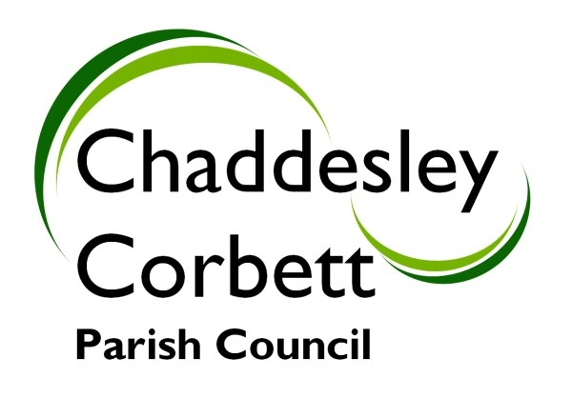


Chaddesley Corbett Parish Council

Annual Report
2008/9

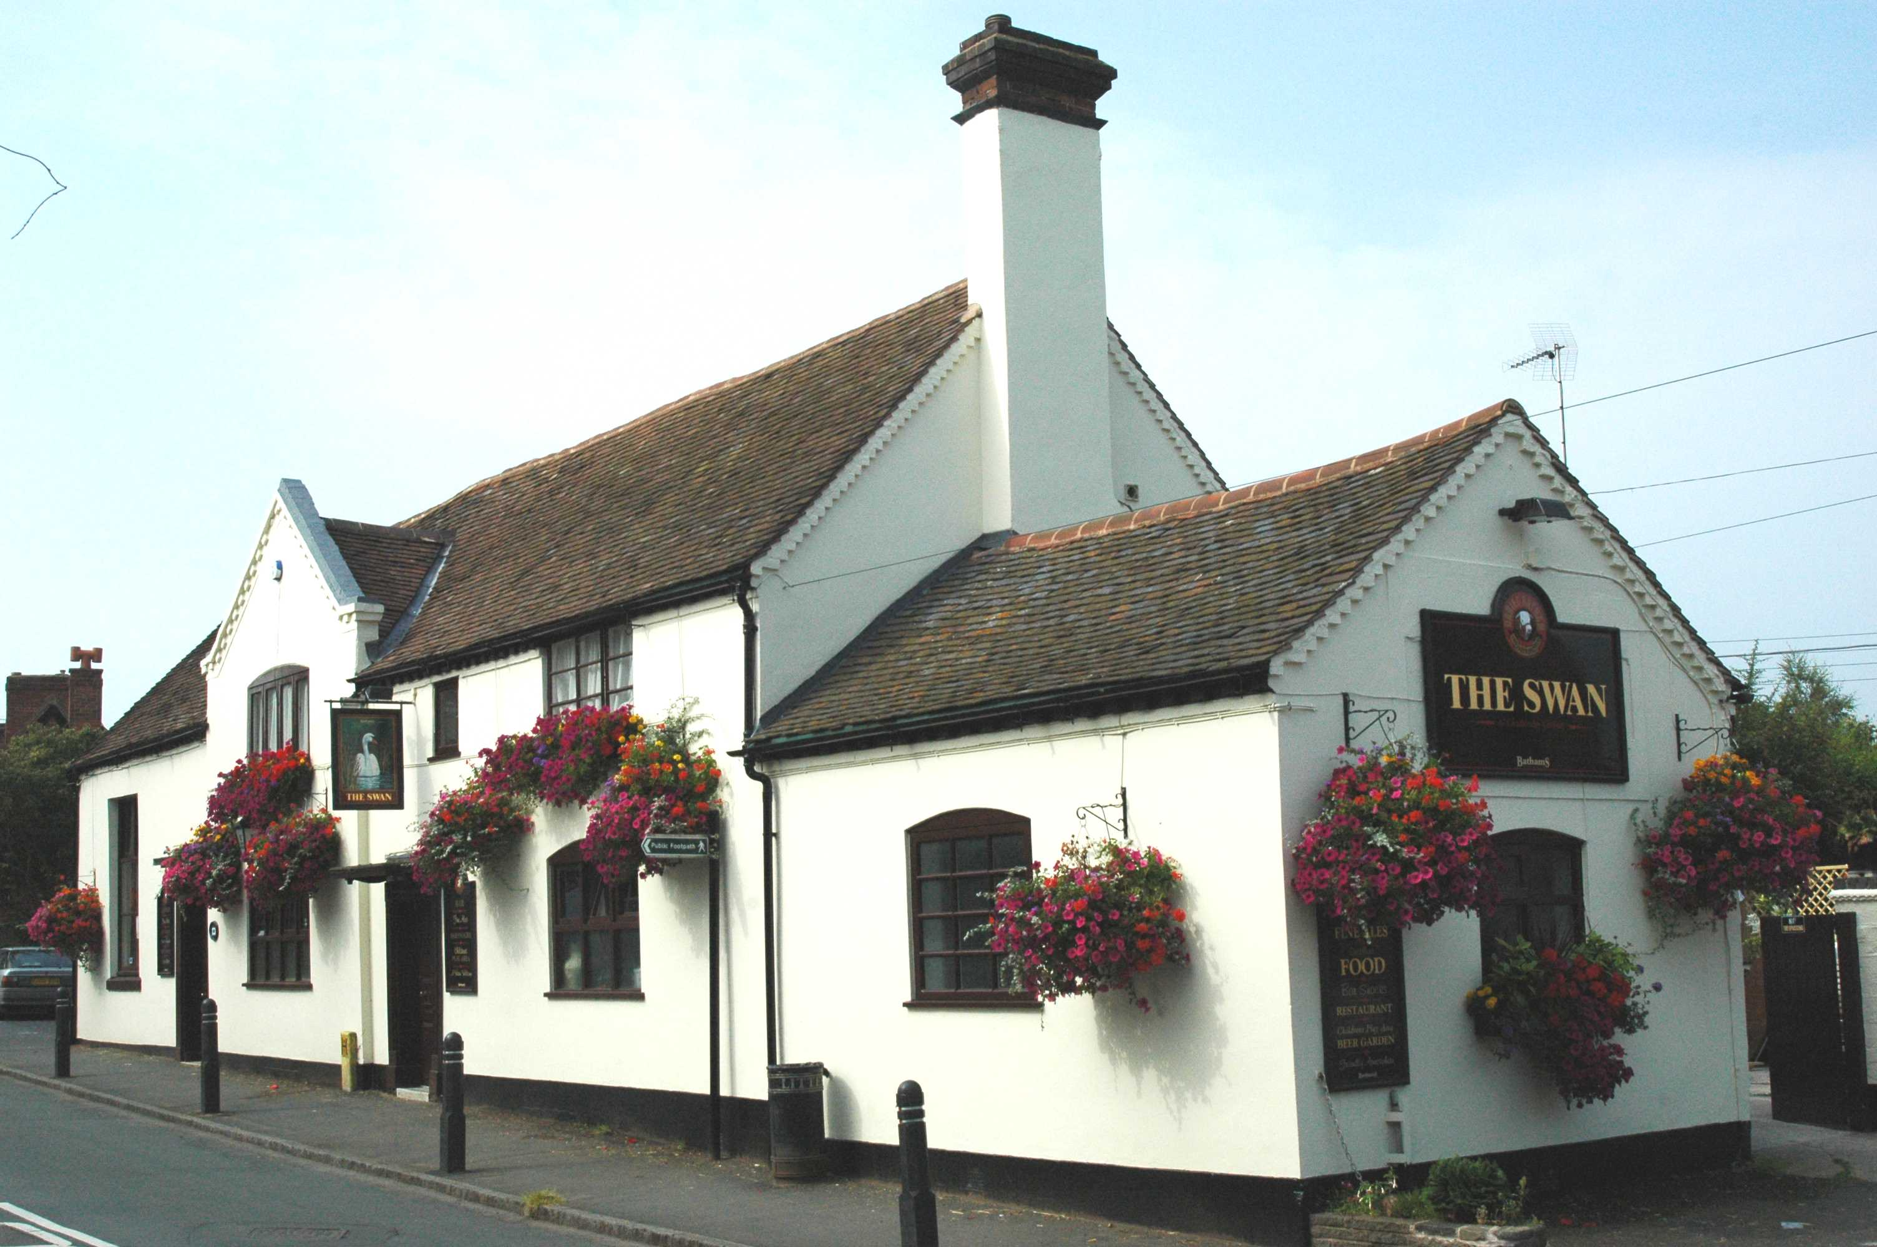

The Parish of Chaddesley Corbett includes:

The Village, Bellington, Bluntington, Brockencote
Cakebole, Hill Pool, Drayton, Harvington, Lower Chaddesley
Mustow Green (East), Tanwood, Winterfold, Woodrow
The Chairman’s Annual Report

It has not been an easy time operating as a Parish Council in an increasingly bureaucratic world, which puts considerable pressure on the available time, which your volunteer councillors have to offer.

We have faced highly complex consultation papers and done our best to contribute commonsense in the face of intimidating proposals. It is, of course, too soon to know how effective we may have been, along with others, to draw up a plan for the future of this rural Parish. Generally, I have the impression that we are more in control. Our contribution to the regional presence is a greater asset than is generally recognised and happily we are more buoyant than some of our neighbours, but then we have perhaps more at risk. We need to find ways to sustain and even enhance the Parish and the community. We must ensure that we have the resources to match our ambition, particularly as we approach some very significant changes, including the much talked about car park and the new school, neither of which are going to be easy challenges.

The business of the Parish Council is essentially sound as we have fought to control our expenditure and, indeed, maintain for two successive years a zero increase in the Parish precept.

I wrote earlier about the tendency towards increasing bureaucracy, the pace of which lies with the example set by some of our leading institutions, e.g. The House of Commons, NHS. We all have to improve our ability to communicate. We have to ensure there are no hiding places. The consensus management is bogging us all down with innumerable meetings when in reality we require strong committed leadership. Similarly we are becoming used to the compensation culture. All too frequently we recognise the ‘No win, no fee’ offer, and whilst we need to reflect the reality of this century rather than the last, the Parish Council is finding an appropriate way to add commonsense, popular opinion, greater efficiency, and to be more professional and competent to meet the regulatory burden imposed from a great height, whilst representing the residents and businesses of this Parish.

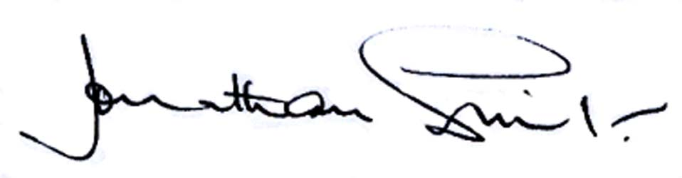

Annual Parish Meeting
The Annual Parish Meeting was held on Wednesday 20 May 2009 and attended by Parish Councillors and more than 40 residents. A range of speakers addressed the meeting and residents had an opportunity to raise matters of concern. A full report on matters raised at the meeting is included in this Report.

Communication
As a Quality Parish Council, we are committed to better communications with residents; we have a very informative website where you can find out about all current planning applications, with a direct link to the District Council web site, Minutes of Parish Council meetings, Agenda for forthcoming meetings and consultation documents. Our website is available on www.chaddesleyparishcouncil.org.uk In addition we have a comprehensive website hosted by Worcestershire County Council; visit www.worcestershire.gov.uk/My Parish and enter your postcode.

If you don’t yet have access to the internet, copies of Minutes of Meetings and other items of interest can be found on one of our three Parish Council Notices Boards situated in the Village of Chaddesley Corbett, Drayton and on the A458 at Harvington.

Police and Neighbourhood Watch
In order to improve community engagement, PC Sally Sliwinska and CPO Kate Easthope, who have particular skills and knowledge around engaging with rural communities, have been appointed to our area.

Under our Neighbourhood Watch scheme, the Kidderminster Rural Local Policing Team keep us informed by e-mail of incidents of crime in the area. If you would like to receive these Alerts, please contact the Clerk who will include your e-mail address on the distribution list.

Recently there have been a number of shed and garden thefts and residents should consider taking preventative measures such as:

- Install security lighting
- Gates and garages to be locked
- Keep hedges trimmed
- Use defensive plants
- Chain up bicycles and other large items
- Don’t leave ladders outside
- Check household insurance covers items in your garden
- Property marking

The Police take anti-social behaviour very seriously as they understand that it can effect quality of life. Please report any incident so action can be taken.

Your local policing team are:

PC 299 Sally Sliwinska – Local Policing Officer
CSO 6239 Kate Easthope – Community Support Officer

Contact details: Kidderminster Police Station, Habberley Road, Kidderminster DY11 6AN, phone 0300 333 3000 or 01562 828290. E-mail: Cookleyandwolverley.1pt@westmercia.pnn.police.uk

PARKING IN THE VILLAGE
Our Parish Plan includes a vision for the Parish’s roads, including
    - Adequate parking (especially off road), and
    - Adequate public transport

Residents, businesses and other employers in the village have carried out a range of practical actions that continue to help minimise congestion. In addition a series of minor parking restrictions were suggested
- to restrict parking where it can aggravate congestion
- create passing places for traffic passing through the village
- achieve this with a minimum of signs and road markings
The consultation process has now been completed and we are awaiting the outcome.

Off Street Parking
Last year we also looked at possible sites for a village car park. The preferred option has not changed – the land behind the Swan Car Park.
Establishing a car park will not be easy;

- Planning is restricted by the regulations for a conservation area and the green belt
- The land is privately owned, but needs an access across land owned by a charitable Trust.

Significant progress has been made, establishing that use of this site is feasible. To move ahead, detailed proposals need to be drafted and agreed by the parties concerned, and a successful Planning application will have to be made.

Before incurring significant costs we need to assess the likely cost of the project and look at potential sources of funding. Once we are confident that the project is potentially affordable we will develop more detailed proposals and, of course, make sure that parishioners are informed and consulted.

Responding to questions raised, if a car park was provided, further measures may need to be taken to ensure it would be used by residents and visitors.
Cllr Dave Thomas.

EDUCTION FOUNDATION REPORT ON NEW SCHOOL
In the year the Education Foundation Trust had successfully obtained planning permission on the site next to Rowberrys for a new school but there were issues with highways which had to be dealt with. Architects and highway consultants worked with County Highways to gain a design satisfactory to them for the access junction onto the A448.
There was still a requirement for a 4 metre wide, tarmaced and lit cycleway from the village to the new school. The ‘Travel to School Plan’ for Chaddesley School prepared by the Local Education Authority (LEA) states that children under the age of 11 years should not be encouraged to cycle to school and following a meeting with Wyre Forest District Council the Planning Committee removed this condition. There will now be an upgraded surface with better drainage to the footpath that already exists, and it will remain a footpath not a cycleway.
£3.5 million has been allocated by the LEA to the project, and the Education Foundation Trust would have to provide any shortfall. As the Foundation is governed by Charity Law and they stipulated that money from the Foundation could not be spent to assist the Local Education Authority with the basic costs of building a new school as the LEA’s responsibilities were clearly laid out in the Education Acts.
A report was received at the end of April which supports the Trustees by stating that the site next to Rowberry’s Nursery is the best of the nine possible sites identified in 2005, and that the present school site is not suitable for an enlarged school. However, the LEA has set aside funds sufficient only to build a BB99 school, without any allowance for the cost of services on a new site, therefore there is not enough money to carry out the project. The decision of the LEA is to look again at any possible ways of developing the present site, by taking in the neighbouring field and by providing access via the Swan Car Park. The representatives of the Foundation and the school expressed their astonishment and extreme disappointment at this outcome, and a letter has been sent to Cllr George Lord.
The Trustees strongly believe that their involvement is extremely important to ensure the interests of Chaddesley Corbett village specifically, and the community generally, are given prime consideration in any changes implemented by the LEA. The Trust has made it very clear that an extension to the current site is not feasible without a plan to manage the additional traffic and consequential parking problems.
This position has not changed and the Trustees will continue to press LEA Officers to find the money to honour their commitment to provide the new school, so long promised for Chaddesley.
Andrew Page

X133 BUS SERVICE
The Parish Plan Vision statement refers to adequate public transport for parishioners. Around the middle of last year, the limited bus services routed through the village came under threat due to low passenger numbers and poor profitability. This service was not covered by any contract with the County Council, and so the decision could be made unilaterally by the operator.

The Parish Council formed a working party to look into the situation, and carried out a survey of parishioners who use the service, to understand their needs and concerns. The survey results emphasised both the need for access to local towns and also the need for links between Harvington and the Village.

Working through the WCC Passenger Transport team, we were able to agree changes to the number and timing of the services routed through the village. To ensure that these services operated throughout the first quarter of 2009, the Parish Council agreed to fund the £300 subsidy to the bus operator.

Proposals for a new service were also discussed, and the WCC Passenger Transport team have now let a contract for the 133 service, which started on 12 April. This service requires no subsidy from the Parish Council, and offers access to Droitwich as well as Kidderminster; 8 buses a day (4 in each direction) now run through the village, Monday to Saturday. Existing services via the A448 will continue as before. Timetables have been placed on all notice boards and bus stops, and a copy was posted to the people that replied to our survey of users.

Feedback about the service has varied, but is generally positive. We are grateful to the WCC Passenger Transport team for their positive attitude and help in maintaining a public transport service for the Parish.
Cllr Dave Thomas

LENGTHSMAN SCHEME
The scheme is implemented by Bill Waldren, our Lengthsman whose work can be witnessed all around the Parish. After much pressure the watercourse in Lower Fox Lane has been cleared with the co-operation of Severn Trent Water and the District Council, which should resolve an age-old problem.

The dam below the bridge at Hockley Brook has been substantially lowered which should also alleviate any further problems in this area and thanks are extended to all interested parties.

Some ditching work was carried out during the year using funds provided by the County Council, and thanks to County Council Highways many of our drains/watercourses have been jetted and a camera survey made, which identified seven serious problems. Despite numerous communications, site visits and discussions, a year has passed and we have been unable to secure a positive itemized commitment or time scale for these works to be carried out. The biggest problem is the A448 on the junction with Fox Lane, and whilst there are budget restrictions at the County Council, we will continue to press for some action.
Cllr Geoff Vernon

Environmental Group
The Group had written various articles for Parish magazine, mainly by Martin Kenrick, and they would welcome suggestions from anyone in the Parish who would like to contribute. The Group has reviewed the Worcestershire County Council’s Waste Core Strategy and note that zero landfill is the ultimate objective. The battery collection service has been very successful and has been changed so that batteries are disposed of by Wyre Forest District Council at no cost to the Parish. This service is available to all within the Post Office.

The new school gives a real opportunity to exploit “state of the art” technologies, including insulation – under floor heating, roof space, double/triple glazing, combined heat and power technology, ground source heat pumps, photovoltaic water heating, energy efficient lighting with sophisticated control systems and the harvesting of rainwater. The Group believes that good design at the outset will enable further improvements in the infrastructure of the school to be exploited in the future, at least cost and disturbance, thereby saving more money. Benefits manifest themselves in hard cash – quite apart from the moral educational and environmental intangibles, which must be worthwhile. They would welcome involvement in the design of the new school.

Tom Westley

Affordable Housing
The Parish Council formed a working party to see if there was a need for Affordable Housing, and with the assistance of the District Enabler, Nigel Potter, we commissioned a Housing Needs Survey.

The Enabler confirmed that a genuine need had been identified for a number of properties for shared ownership and rent. It was felt that residents with a local connection who were unable to qualify on points for properties could benefit if affordable properties for shared ownership or rent were available. Such properties would never be sold and would be available in perpetuity only to local people, or those with local connections. On this basis the Parish Council unanimously agreed to consider the provision of a small number of properties situated in developments of 3 or 4 properties, on infill sites, around the Parish for rent or shared ownership.

The next step is to have a meeting with the Enabler. This has not happened because the Enabler has been ill as the result of a car accident. We are still waiting to hear from him about our next meeting.
Cllr Ken Bartlett

LOCAL DEVELOPMENT FRAMEWORK
WYRE FOREST DISTRICT COUNCIL
Rebecca Mayman (Wyre Forest District Council) gave a presentation on the Consultation Papers with regard to:
- Core Strategy -Preferred Options Paper
- Site Allocations and Policies -Issues and Options Paper
- Kidderminster Central Area Action Plan Development Plan Documents (DPD) – Issues and Options Paper
- Core Strategy Draft Sustainability Appraisal Report

‘What does it mean for Chaddesley Corbett in the Future?”
- Identified as a village in the settlement hierarchy
- Types of development suitable in the future limited to housing to meet local needs and the provision of appropriate local services
- Identification of a site(s) specifically for the provision of affordable housing through the Site Allocations and Policies DPD.
- A proactive approach to small scale live/work units and the conversion of redundant agricultural buildings to rural workspaces
- Using the Parish Design Statement to inform policies on local distinctiveness
- Stringent requirements for sustainable development standards
- Landscape character and safeguarding best and most versatile agricultural land
- Promoting opportunities for sustainable development
- Promotion of community facilities and shared use to provide cultural facilities in rural settlements
- Create and enhance green infrastructure to promote opportunities for biodiversity and recreation

The LDF Consultation had consisted of exhibitions and several hundred comments had been received from residents and consultees throughout the District. An exhibition had been held at Chaddesley on 4 February where discussions focused on a suitable site for the provision of affordable housing, a car park for the village, the new school site and how the Parish Design Statement could influence the LDF.

Specific Issues Arising from the Consultation
- Concerns that the roads are unsuitable for the volumes of heavy traffic that could derive from distributive businesses. However, some small scale commercial services and professional use could be appropriate.
- It was considered that opportunities for tourism were limited, exacerbated by limited car parking space.

- A number of new sites had been suggested for small scale affordable housing provision. For example, the Margaret Delabere Almshouses; land belonging to Brockencote Hall Hotel; land adjacent to the petrol station and land adjacent to the community hall at Harvington.
- It was suggested that the redundant farm buildings at Briar Hill could be used for commercial uses.

What has happened to the responses?
Core Strategy
- All responses on the Core Strategy have been fully considered by Officers and reported to Members in April.
- A summary of the responses is available to view on the Council’s website.
- Responses will help to formulate the Submission version of the Core Strategy.

Site Allocations & Policies and Kidderminster Central Area Action Plan
- All responses on these DPDs are to be reported to Members in June
- A summary of the responses will be available to view and download from the Council’s website at the end of June.
- Responses will help to formulate the next stages of these documents – the Preferred Options Stage.
- Further consultation will take place on these documents in 2010.

Next Steps
- Completing the evidence-based studies including the Strategic Housing Land Availability Assessment.
- Awaiting the Panel Report from the RSS Phase 2 Revision Examination In Public.
- Finalising the submission version of the Core Strategy.
- Anticipated submission to the Secretary of State for Independent Examination early in 2010.
- Core Strategy adopted late 2010
- Developing the preferred options for Site Allocations and the Kidderminster Central Area Action Plan.
- Considering alternative sites put forward at this stage of consultation on Site Allocations.
- A further round of consultation on Site specific allocations in 2010.
- Emphasis on continual engagement.
Contact Details: Rebecca.Mayman@wyreforestdc.gov.uk
Heather.Stone@wyreforestdc.gov.uk - Telephone 01562 732554/732520

EMERGENCY PLAN
In co-operation with Wyre Forest District Council the Parish Council have prepared a Community Emergency Plan. Within a broad framework identified by the District, the plan includes:

- Identified possible risks to the community
- Relevant response arrangements
- Resources available to assist
- Key contacts for the Emergency Services and Local Authorities

The Community Response Team comprises:
Co-Ordinator Jonathan Swift
Deputy Co-Ordinator Ken Bartlett
Team Member and registered Child Chaperone Phyllis Pardoe
Parish Councillor Janet Fox
Parish Councillor Richard Pugh
Clerk Yvonne Scriven

The Plan provides key information for use in the event of an emergency, including:
Risk Assessments
Key Contact List
Community Resources
Householders Emergency Plan
Communications
Maps of the Community
Plan Distribution

Bearing in mind the Freedom of Information Act and Data Protection rules, we need to identify ‘vulnerable groups’ who might need assistance in the event of an emergency. Anyone who might wish to be included on this ‘secure’ list, or could be nominated with their permission, should contact the Clerk.
Cllr Jonathan Swift

PARISH FOOTPATHS
The County Council have cut the budget for this scheme this year and would only fund 50% of the work required. The Parish Council have decided that is is unacceptable to reduce maintenance on footpaths and will therefore make up the deficit. The Parish leaflet, although completed by the County Council has not yet been published.
Sandi Holding, Parish Footpaths Warden

FAIR TRADE INITIATIVE
Wyre Forest District Council has adopted the Fair Trade initiative and has encouraged Parish and Town Councils to support the initiative. Fair Trade is an organised social movement and market-based approach that aims to help producers in developing countries and promote sustainability. The movement advocates the payment of a ‘fair price’ as well as social and environmental standards in areas related to the production of a wide variety of goods. It focuses in particular on exports from developing countries to developed countries, most notably handicrafts, coffee, cocoa, sugar, tea, bananas, honey, cotton, wine, fresh fruit, chocolate and flowers. If we wish to become a recognised supporter we need to form a Committee or Advisory Group, which will report to the Council and promote Fair Trade to businesses, retailers, schools, clubs and other organisations, and monitor and encourage uptake. Anyone interested in forming such a group should contact the Clerk.
Cllr Jonathan Swift

Allotments and Community Orchard
Currently all 32 plots are rented out, and there is a waiting list, although all local residents have been accommodated. Water was provided last year and so far all costs are covered by the rent. There is a great community spirit with people sharing seeds, produce, and knowledge and occupants have formed an allotment association.

The community orchard is now established and the first 112 trees were planted by more than 64 members of the parish. This was followed up by Chaddesley Corbett Preschool planting the remaining trees the week after. So far we have planted a variety of local trees, which cost £1,319 and we currently have £1182.85 in the bank. Another fund raising event will be held in August and there will be a meeting after this event to decide what trees we will be planting next January. These will be planted in the middle area of the orchard in a medium size root stock; this will allow the trees to capture the sun during the day

The grass will be cut twice a year to control the weeds, first cut to take place middle of June. This maintenance of the site should help to control the spread of weeds on the site by stopping seeding. The end goal is to cut path ways through the orchard so people can walk through and enjoy the orchard and wildlife.

The community orchard is administered within the Parish Council’s accounts to make use of the public liability insurance

If anyone would like to make any suggestions regarding the project please let the clerk know and it can be discussed at the next Orchard meeting. Thanks were expressed to everyone who donated or helped with the project in any way.

It was suggested that a sign should be placed on the site to indicate what it was and that it had been provided by public donations.
Cllr Leo Stockford

Burial Ground
The burial ground has been kept very tidy this year but some people are still not using the waste container. We will be placing a notice on the site stating that all rubbish must be placed in the receptacle provided.

More than 40 plots are in breach of the burial rules which state that the plot must be kept grassed and flat for easy maintenance. We would like owners to comply with the rules themselves, but when they are no longer tended, the Parish Council will have these plots levelled and grassed.
At the last Parish Council meeting it was agreed that owners would be advised that when these plots are no longer tended they will be levelled and grassed and the cost passed on to the owners.
Cllr Ken Bartlett

Parish Games
For several years, Hilary Boden of the Talbot Inn has organised the Pairsh entry into Wyre Forest District Council’s Parish Games. This year they have been particularly successful and with one event to go – the Quiz – they are currently in joint 3rd place. Support for the Games is growing and those who have participated in the various activities have enjoyed it. Crib and dominoe players are still needed, and we have done well in bridge, archery and short mat bowls, although golf needs more support. The junior 5 a-side football team turned out in extremely cold weather and found themselves playing against proper junior league football teams; they did well gaining third place. Thanks were expressed to all who took part, and anyone interested in participating next year should contact Hilary Boden. The Chairman thanked Hilary for organizing these events on behalf of the Parish.

Financial Report
Annual Audit
This will take place on 30 June 2009 and records may be inspected by contacting the Clerk. There has been no increase in the Precept for the second consecutive year..

A summary of the accounts for the year ended March 2009 is given below:

Receipts
Annual Precept £21,783
Section 136 Funding £ 3,267
Donations (Community Orchard) £ 2,362
Burial Ground £ 2,568
Refund VAT (2 years) £ 3,381
Interest on Deposit Account £ 685
Parish Footpaths £ 1,500
Lengthsman Scheme £ 3,156
Urban Grass Cutting £ 1,150
Allotment Fees £ 540
Other Receipts £ 400
TOTAL £40,792

Expenditure
Clerk’s salary £ 6,231
Expenses, mileage, etc. £ 548
Parish Design Statement £ 629
Battery Collection £ 225
Administration/Communication/Meetings £ 3,766
Insurance/Subscriptions/Audit £ 1,823
Lengthsman Scheme £ 4,407
Allotments £ 523
Burial Ground £ 1,532
Parish Paths £ 2,800
Donations £ 800
Maintenance £ 579
Urban Grass Cutting £ 1,133
Trees for Community Orchard £ 1,319
VAT Recovered £ 1,438
TOTAL £27,753

Report by Steve Williams, District Councillor, Wyre Forest District Council, Blakedown and Chaddesley Ward.
I have undertaken 137 engagements as Chairman of Wyre Forest District Council in the last year, the majority of which I have been accompanied by my wife as Consort. During the year we have met the Duke of Kent, Prince Charles and the Duchess of Cornwall. During a long conversation with Prince Charles, I did manage to mention Chaddesley Corbett twice. Other highlights include our Civic Advent Carol Service at St Cassian’s and our Civic Charity Dinner at Stone Manor, which raised £1835 for the Prostate Cancer Support Group in Kidderminster. Along with the Mayor of Kidderminster, I jointly funded a Sports Award Ceremony for local athletes and opened the refurbished Bewdley Museum and Stourport Sports Club.

During the last 12 months I have attended other Parish Councils within my ward whilst being present at all Chaddesley Corbett Parish Council meetings. I have been a member of the board of Wyre Forest Sheltered Housing and Community Housing Property Services. I have used my Community Fund wisely in supporting the Parish Council’s printing and distribution costs for the Parish Design Statement and helping the Village Hall refurbish their boiler. I have been able to help parishioners with many and varied matters in the last 12 months and look forward to being of service this year.

Report by Cllr Stephen Clee – Worcestershire County Council
I hold the post of Cabinet Member with responsibility for Corporate Services at County Hall and my fellow Councillors and I continue to ensure that everything we do is to give value for money to all the taxpayers in Worcestershire. We continue to work very closely with Wyre Forest District Council, which is a Conservative run council, and one that is regarded at County as being visionary and forward thinking compared to some of the other districts in Worcestershire.

Following the latest Comprehensive Performance Assessment (CPA), the County Council has been rated EXCELLENT and rated 4 stars on how it delivers services across all directorates. Out of 39 local authorities we are the best performing Council in the whole of the West Midlands. Although we are rated “excellent” government do not give us the funding we need to provide necessary services. We see a massive shortfall in budget over the next 3 years with £25million pounds needed to be found from efficiency saving across all service directorates.
In Wyre Forest we see £160million being invested by our County Council into new primary and high schools. We have also invested last year £15million into the road improvement budget. Chaddesley saw the Village resurfaced from this funding.

-----------------------------------------------------------------
General Information

WYRE FOREST DISTRICT COUNCIL

Is the credit crunch hitting?
Are you on a low income?
If so, financial help is available……

If you pay rent and/or Council Tax and have a low income you may be entitled to benefits to help you pay your rent and/or Council Tax.

To find out more, please visit The Worcestershire Hub, at the Town Hall, Vicar Street, Kidderminster, or call 01562 732928.

You can go online to www.wyreforstdc.gov.uk where you can apply on line for benefit click on:
Advice & Benefits>Benefits>Benefit forms
And follow the set up instructions.

e-mail the Benefit Section at benefits@wyreforestdc.gov.uk or the Council Tax Section at ctax@wyreforestdc.gov.uk

HOME CHOICE PLUS
A weekly list of homes to let or for shared ownership is available to view in the Village Shop.

USED BATTERY COLLECTION
Please help the environment by disposing of your used batteries in the box provided at the Village Shop.

 | JONATHAN SWIFT  Responsibilities – Chairman.  Telephone: 01562 777268.  jonathanswift10@btinternet.com.
 | KEN BARTLETT  Responsibilities – Vice Chairman, Burial Ground  and Trustee Education Foundation Management Committee  Tel 01562 777 453  kenbartlett@lineone.net
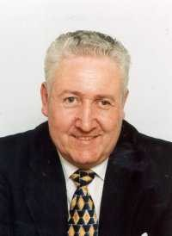 | STEVE WILLIAMS  Responsibilities – District and Parish Councillor,  Charitable Trusts  Telephone: 01562 777536  chaddesleycouncillor@yahoo.co.uk
 | MICHAEL BIRD  Telephone:01562 777728  michaecjlbird@tiscali.co.uk
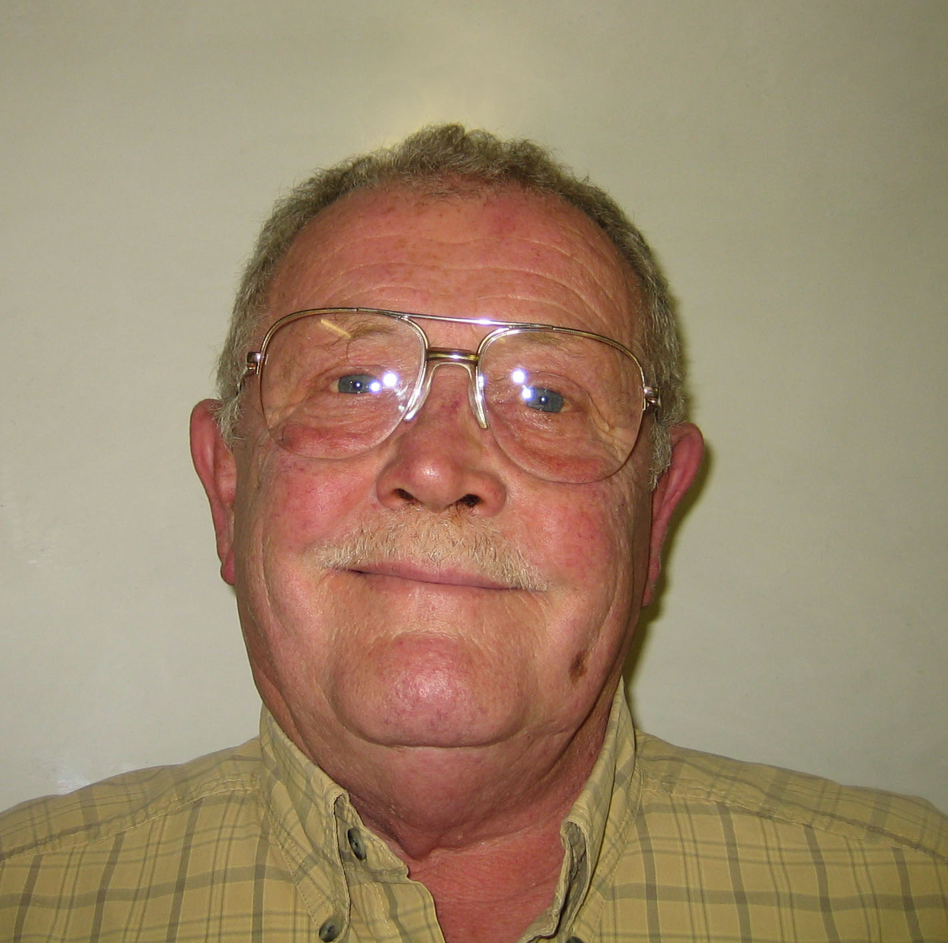 | GEOFF VERNON  Responsibilities - Wyre Forest Community Housing, Tenants Consultative Committee  Lengthsman Scheme  Telephone: 01562 777365
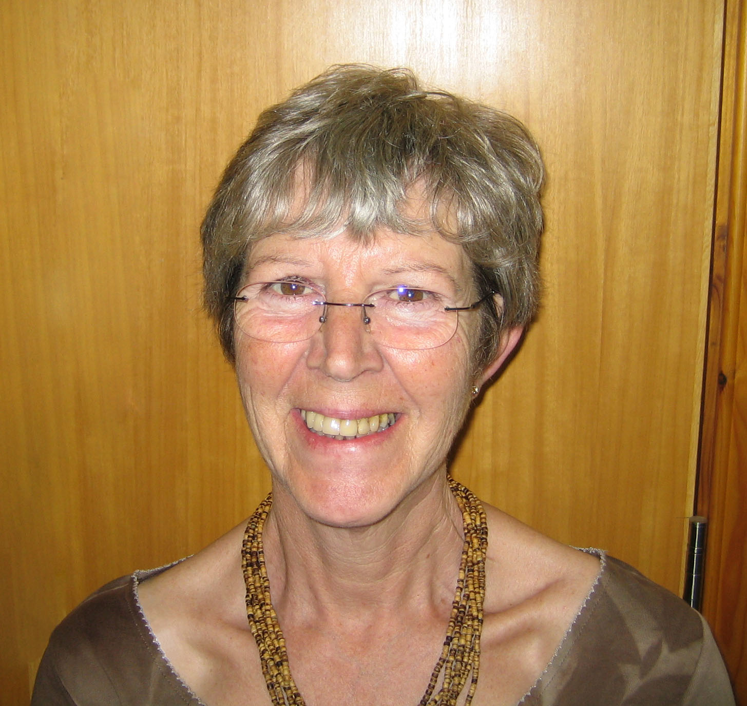 | JANET FOX  Responsibilities – Member of Police  Consultative Committee, PACT  Chairman of Parish Plan Working Group  Telephone 01562 777559.  janfox.fox@virgin.net

 | LEO STOCKFORD  Responsibilities – Allotments,  Chairman, Planning Committee  Telephone: 01562 777746.
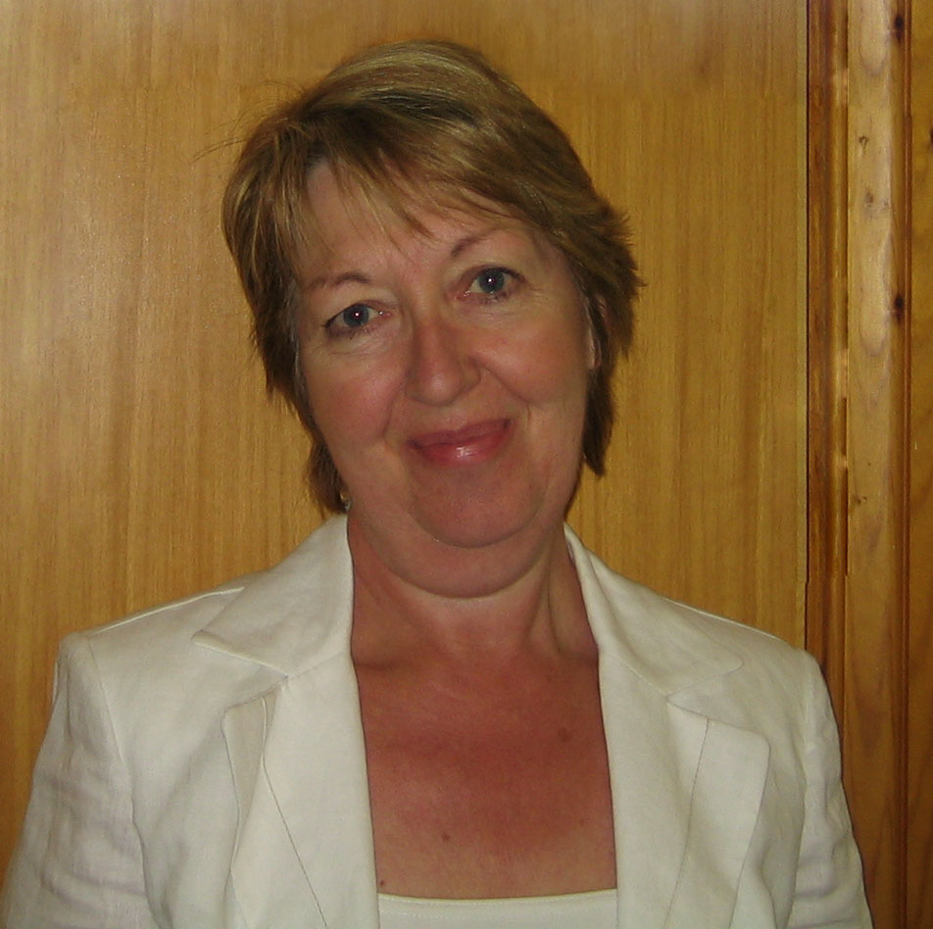 | PHYLLIS PARDOE  Responsibilities – Trustee and Member of the  Village Hall Committee,  Trustee Education Foundation Management  Committee and Margaret Delabare Charity  Telephone: 01562 777969  phyllispardoe@btinternet.com
 | Dave Thomas  Responsibilities - Transport and  Chairman of Working Group on  Parking and Vice Chairman of Planning Committee  Telephone: 01562 777315  david.j.thomas@dsl.pipex.com
 | MARTIN WALFORD  Responsibilities – Representative on  Wyre Forest Area CALC  Telephone: 01562 777325.
 | YVONNE SCRIVEN  Clerk to the Parish Council  Trustee and Treasurer of the Village Hall Committee  Telephone: 01299 851654  Mobile: 07793 621594  Fax: 01299 851444  e-mail: Yvonne.Scriven@btinternet.com.

USEFUL CONTACTS

Bell Ringers Harry Grove 777967
Brownies Kirsty Kirwan 777152
Butcher Mark Page 777244
C.A.T.S. (Secretary) Jackie Brown 777537
Chaddesley Corbett Endowed Primary School
(Headteacher) James Hawthorn 777312
Chaddesley Corbett Educational Foundation
(Clerk) Yolande Biggs 777312
Chaddesley Farmers Club Bill Meredith 777342
Chaddesley Corbett Pre School Nursery
(Supervisor) Rose George 777573
Nursery Phone 777356
Chaddesley Woods Wardens Mervyn Needham 777461
Bernard Cook 777308
Chaddesley Corbett Village Hall (Bookings) Claire Williams (07791) 508283
Conservative Association (Chairman) Jonathan Swift 777268
Cricket Club (Chairman) Ian Vogel 777388
County Councillor Stephen Clee (01299) 402338
District Councillor Stephen Williams 777536
DOCTORS – The Surgery Dr Spalding & Dr. Wilkie 777239
Flower Rota for St. Cassian Rosabelle Needham 777461
Flower Room (Shop) Helen England 777808
Football Club Dave Yardley 632956
Footpath Officer Sandie Holding 777575
Fox Inn James and Michelle Wood 777247
Friends of St. Cassian (Chairman) Mervyn Needham 777461
Friends of the Village Association (Chairman) David Hislop 777493
Gardening Club (Secretary) Audrey Cook 777308
Harvington Hall Office 777846
History Society (Chairman) Robin Blakeway 777679
Hockey Club (Chairman) John Fallows (01299) 403613
Hockey Club – junior (Secretary) William Mack 777343
Laceys Hair & Beauty Appointments 777241
Methodist Chapel, Bluntington John Rhead (01527) 870488
Mothers & Toddlers Kate Collyer (07971) 192126
Neighbourhood Watch (Area Co-ordinator) Malcolm Inchley 770025
Oaks Community Hall, Harvington (Bookings) Shelagh Gardiner 777496
Parochial Church Council (Secretary) Sylvia Beardshaw 777955
Parish Council (Clerk) Yvonne Scriven (01299) 851654
POLICE KIDDERMINSTER 08457 444888
Non Urgent Matters 0300 333 3000
Post Office, Shop & Tea Rooms Chaddesley Richard Vale 777257
Riding for the Disabled Helen Kershaw (01527) 872998
Royal British Legion Maurice Walker 777352
Rugby Football Club - Chairman Mike Wilson 636439
Rugby Club - Junior Section Debbie Newbold 777404
Sports Club Pavilion 777691
St. Mary's RC Church, Harvington Fr. Moran 777319
Swan Inn Roy Fuchco 777302
Talbot Inn Rupert & Hilary Boden 777388
Wednesday Club (Secretary) Margaret Whiteman 748363
WI - Brockencote (President) Ronnie Pardoe 777338
WI - Chaddesley (Secretary) Anna Hanson 742358

Contact details for the Clerk:

Yvonne Scriven
Urloxhey House, Elmbridge,
Worcs WR9 ONQ.
Telephone: 01299 851654
Mobile: 07793 621594
Fax:01299 851444
e-mail: Yvonne.Scriven@btinternet.com.

Parish Council Web-Site: www.chaddesleyparishcouncil.org.uk

Worcestershire Hub: www.worcestershire.gov.uk and enter your postcode.

Village Web-Site: www.chaddesley-corbett.co.uk

